AUTO SCALING GROUP
- Create one VPC in N. Virginia region.
Go to VPC → Your VPCs → Create VPC Choose:
• Name: my-vpc
• IPv4 CIDR: 10.0.0.0/16
• Rest keep default → Create VPC
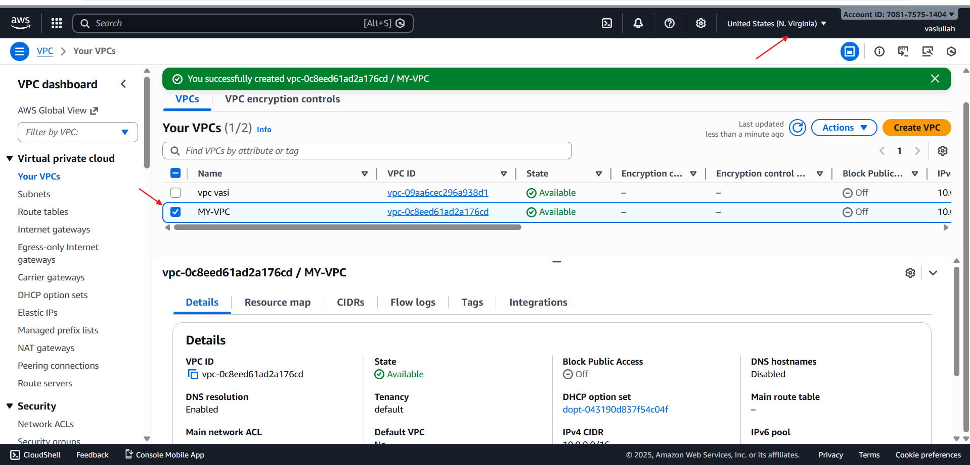

- Create two subnets: one public subnet and one private subnet.

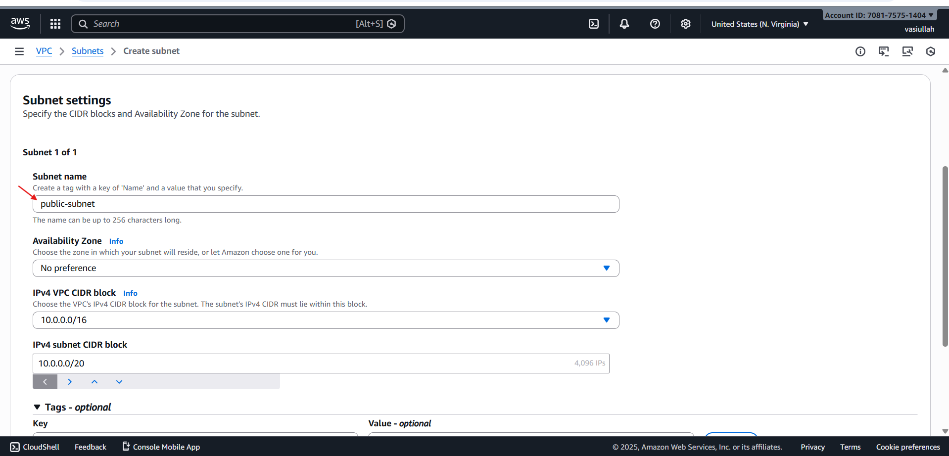

Go to VPC → Subnets → Create subnet Public subnet
• VPC: my-vpc

- Name: public-subvpc1
• AZ: for example us-east-1a
• CIDR: 10.0.1.0/24

- Create Private subnet
• VPC: my-vpc1
• Name: private-subvpc1
• AZ: us-east-1a (same AZ as NAT for lab simplicity)
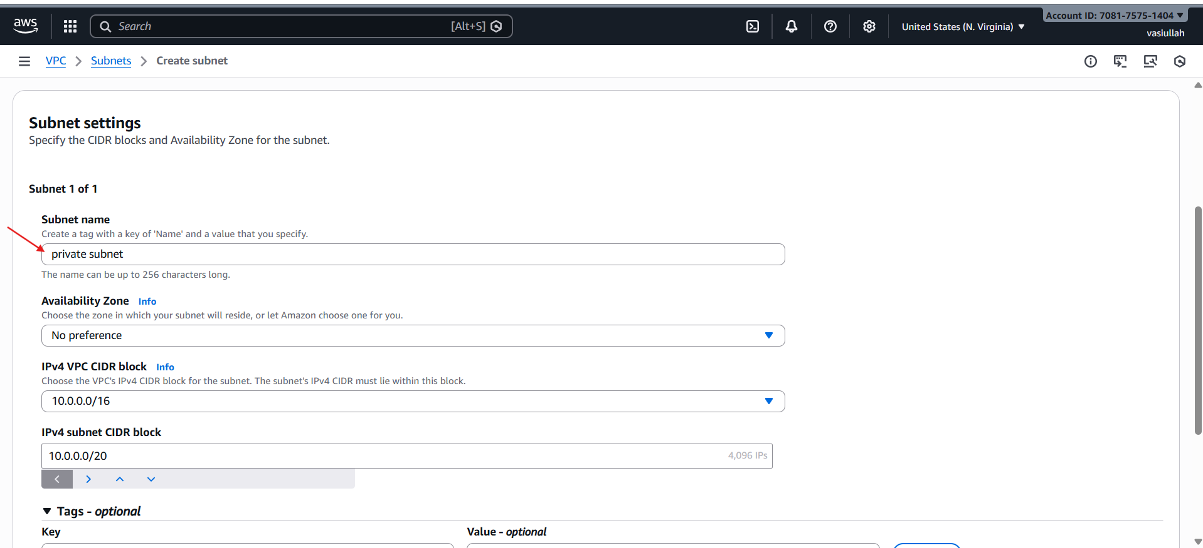
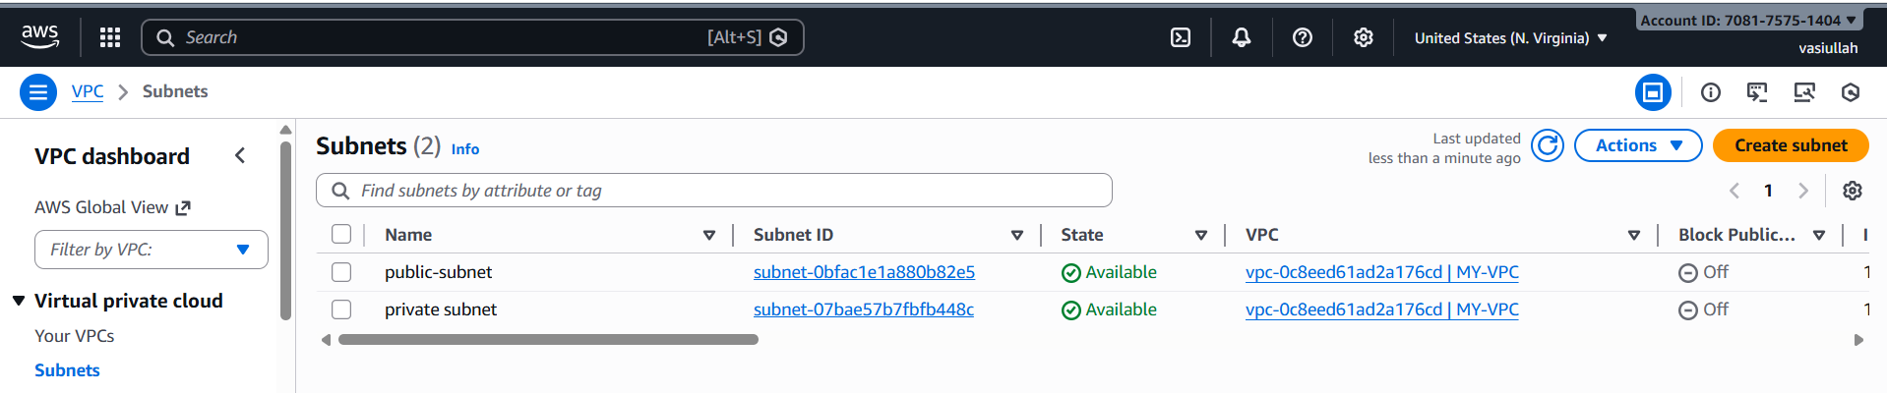

- Attach an IGW to the VPC.

- VPC → Internet gateways → Create internet gateway
◦ Name: myvpc1-igw→ Create 2.
- Select project-igw → Actions → Attach to VPC → choose project-vpc → Attach.
This IGW gives internet to resources in public subnet (through route table).

- attached the igw to the vpc

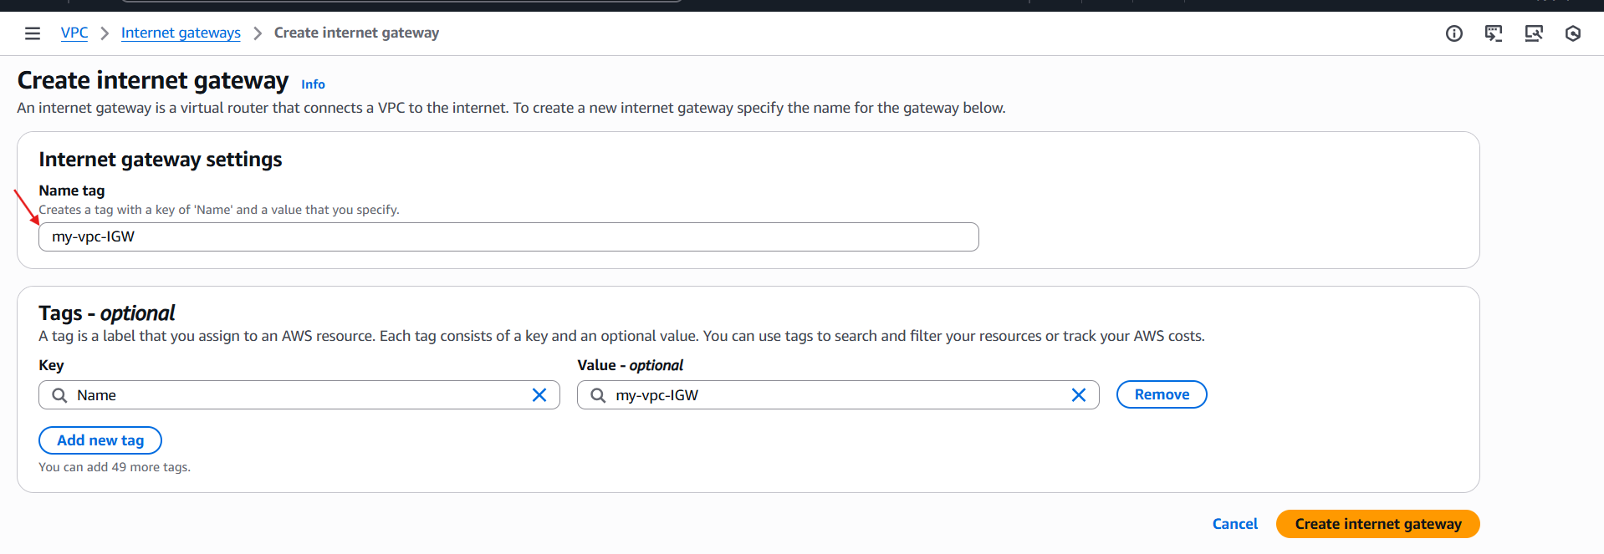
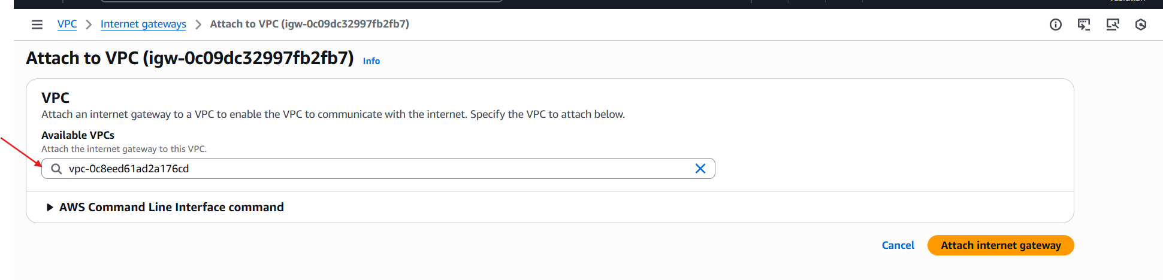
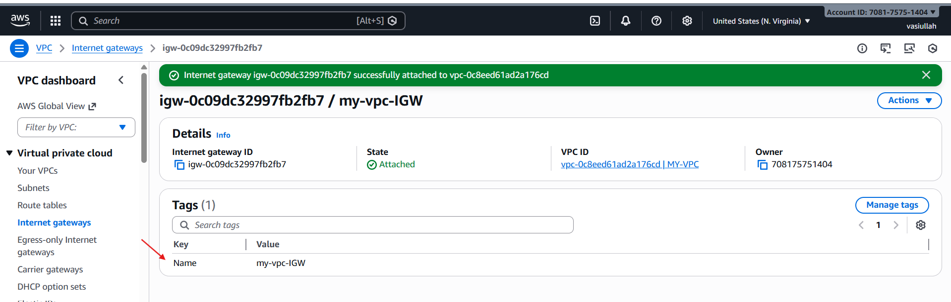

- Create one public route table (RT) and one private route table.

- VPC → Route tables → Create route table
• Name: public-route
• VPC: my-vpc
- Select public-rt → Routes tab → Edit routes:
• Add route:
◦ Destination: 0.0.0.0/0
◦ Target: Internet Gateway (project-igw)
• Save
- Subnet associations tab → Edit:
• Select public-route
• Save

- Private Route Table 1.
Create route table again:
◦ Name: myprivate-route
◦ VPC: my-vpc1 → Create 2.
- (Routing to NAT we’ll do after creating NAT)
- Subnet associations:
◦ Associate private-subnet-1 to private-rt
- private route table is created
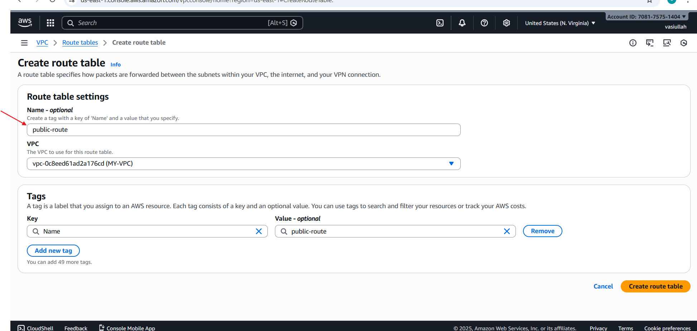
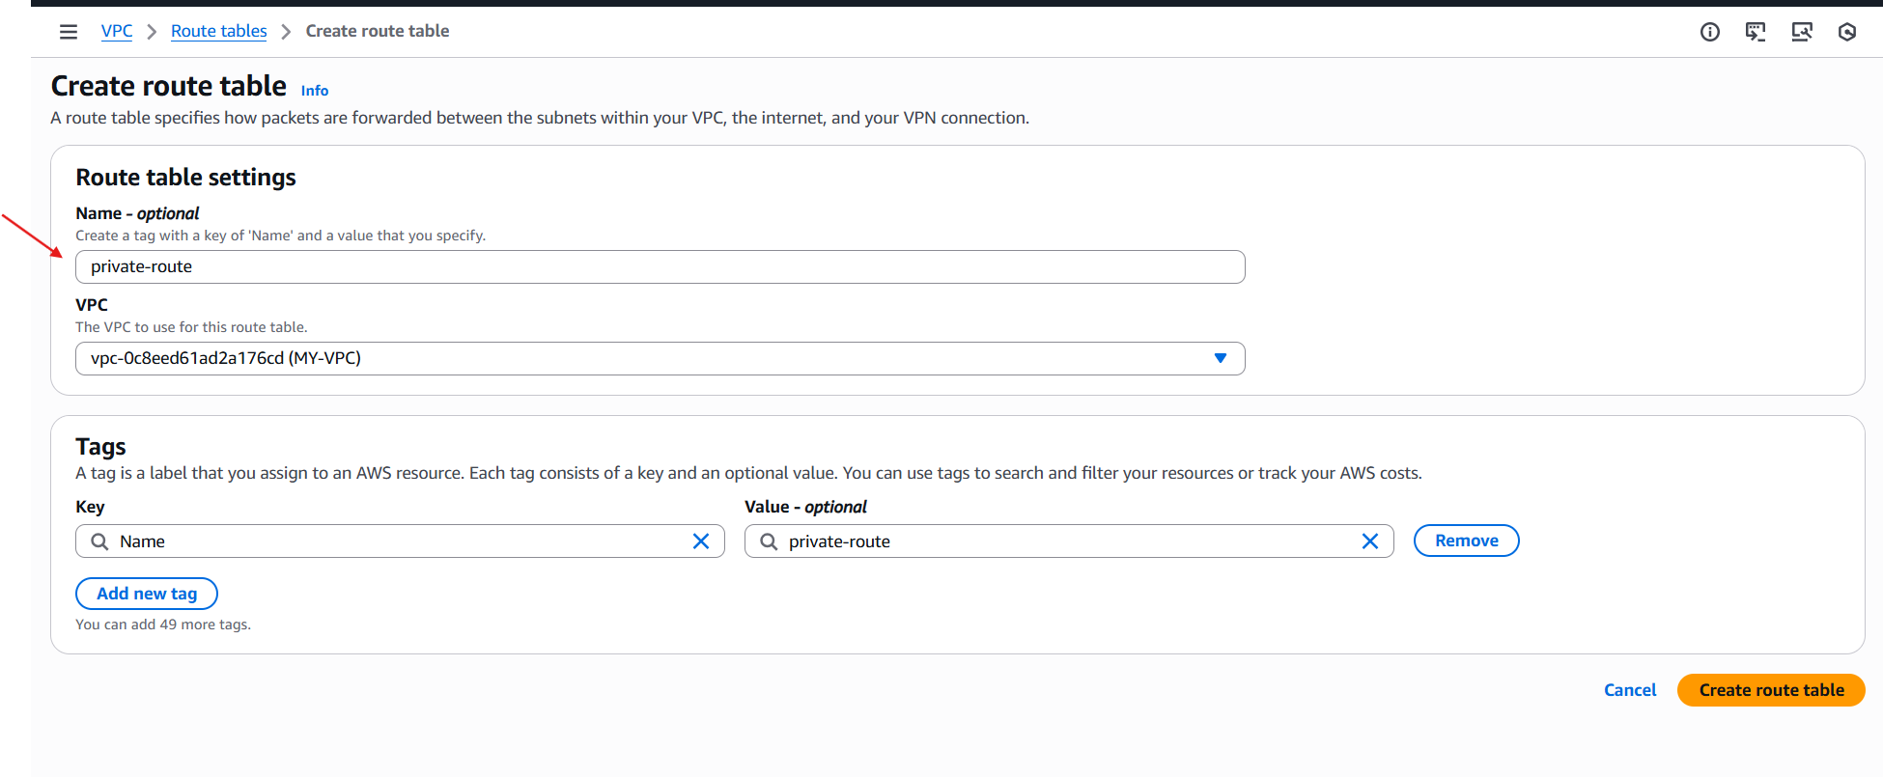
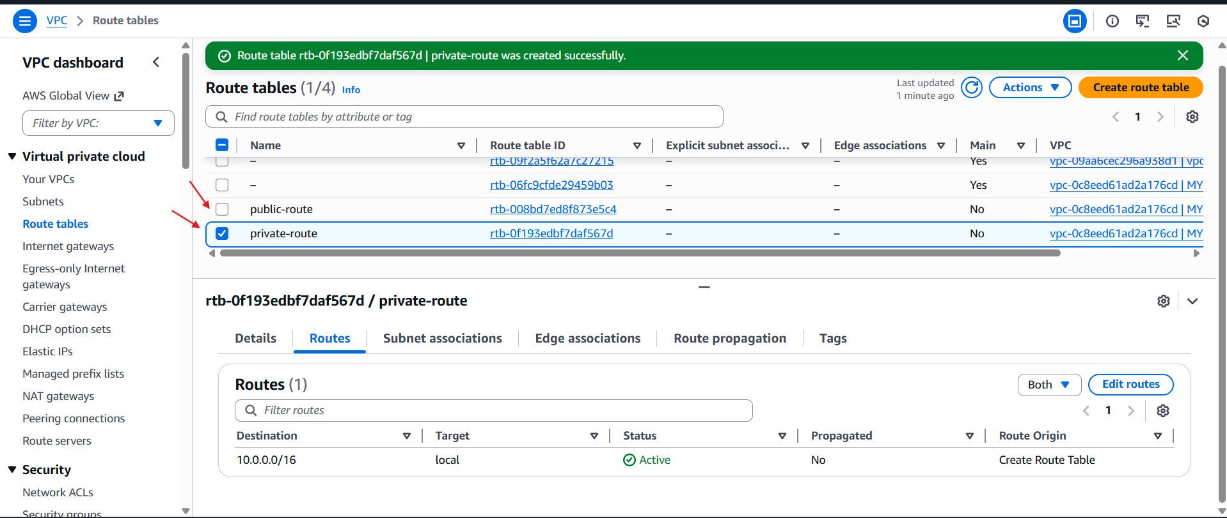

- Deploy a NAT gateway in the public subnet and attach the NAT gateway to the private subnet.

- Go to VPC → NAT gateways → Create NAT gateway
◦ Name: my-nat-gateway
◦ Vpc
◦ Elastic IP: click Allocate Elastic IP and choose it
◦ Create
- After NAT is Available, edit private-rt routes:
◦ Select private-rt → Routes → Edit routes → Add route
▪ Destination: 0.0.0.0/0
▪ Target: NAT Gateway (project-nat)
◦ Save Now private subnet can go out to internet (yum/apt updates) but internet cannot directly reach it.
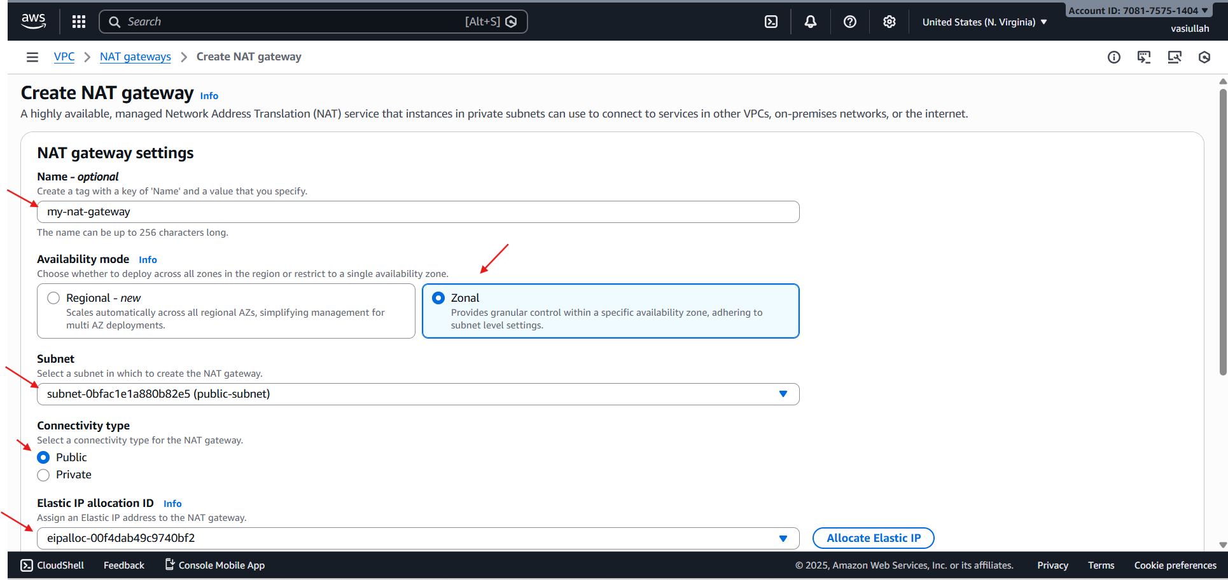

- Go to private route and attach the nat gateway
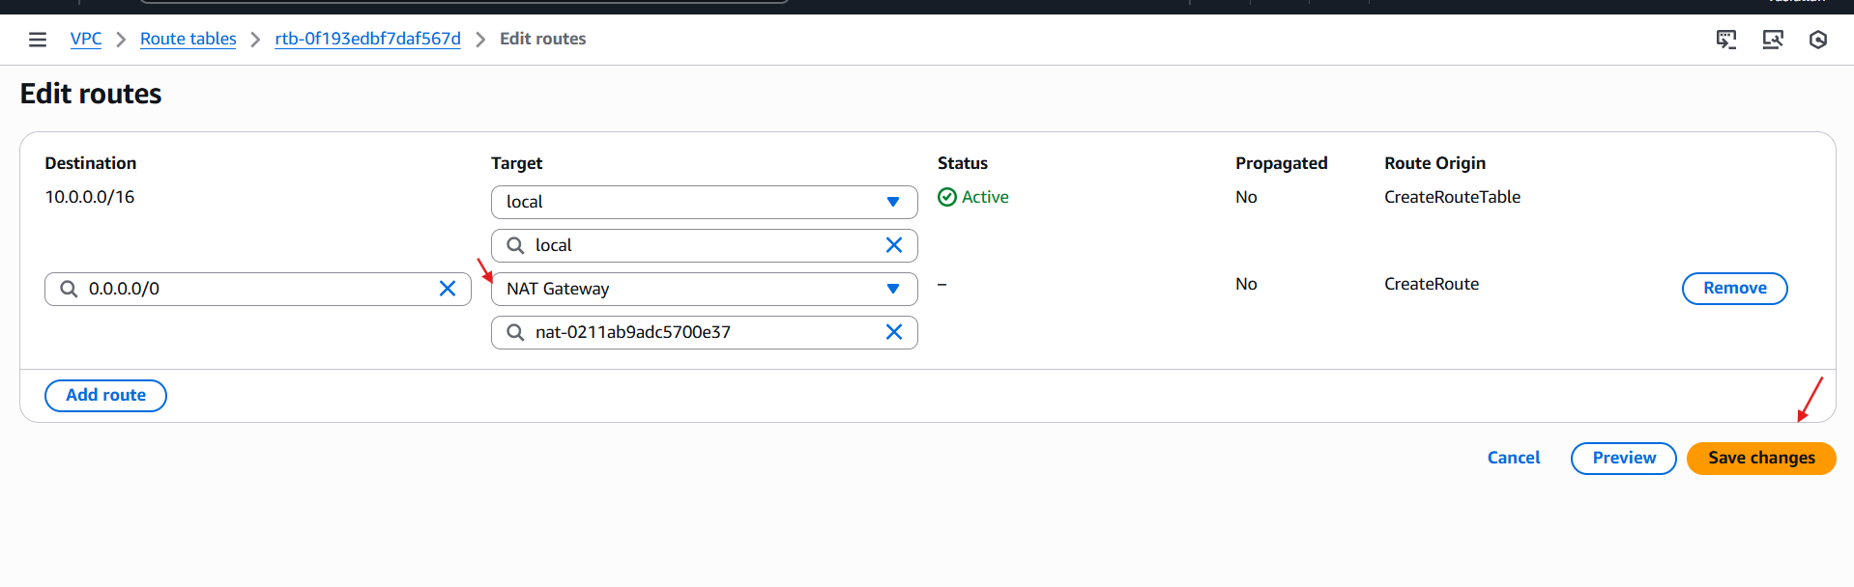
- Nat gate way is attached to the private route table
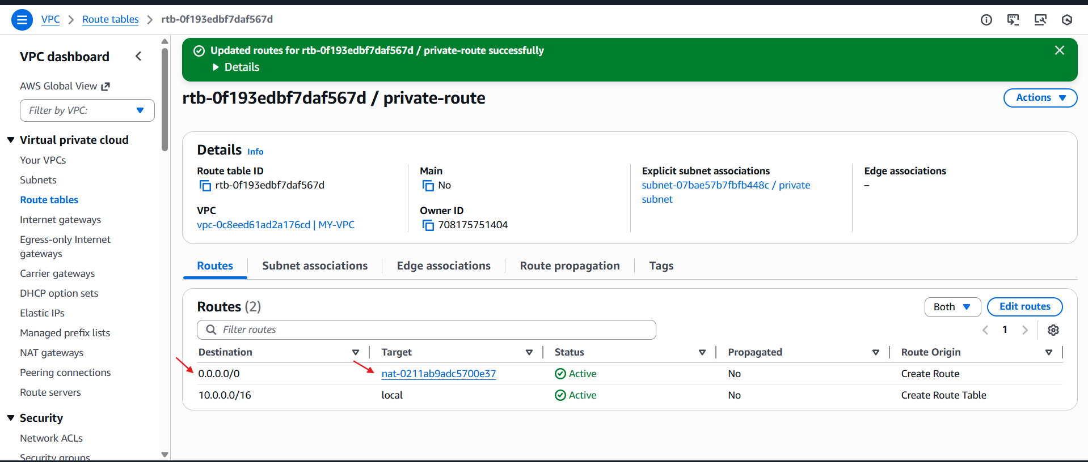

- Create two instances, one in the public subnet and one in the private subnet.

- Steps:
- Create EC2 instances (1 public, 1 private)
- select the vpc which we created and for public ec2 select public subnet
- And for same in private instance choose created vpc and select the private subnet of the vpc
- And launch the instance
- before launching I have added the script for installing httpd apache in data centre from task 7
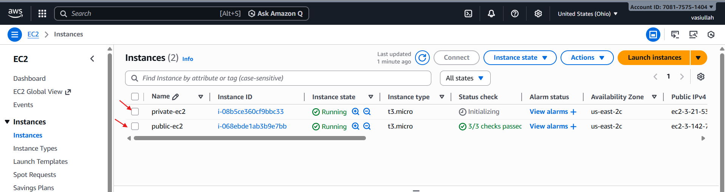

- Deploy Apache server on both EC2 instances with a sample index.html file.

- For public ec2 added the above script
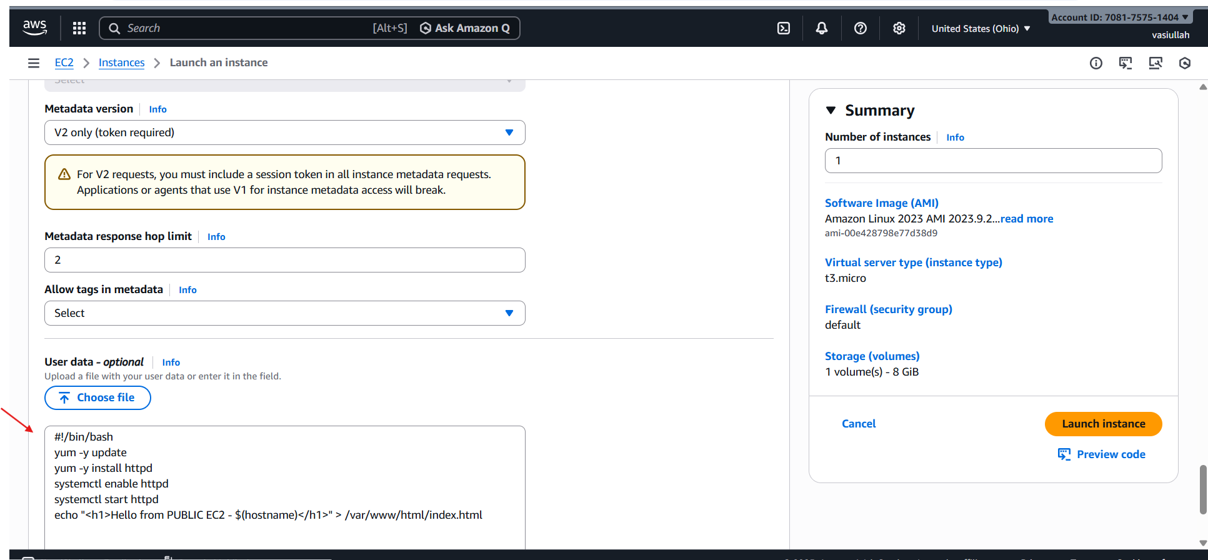
- For private ec2 added the below data
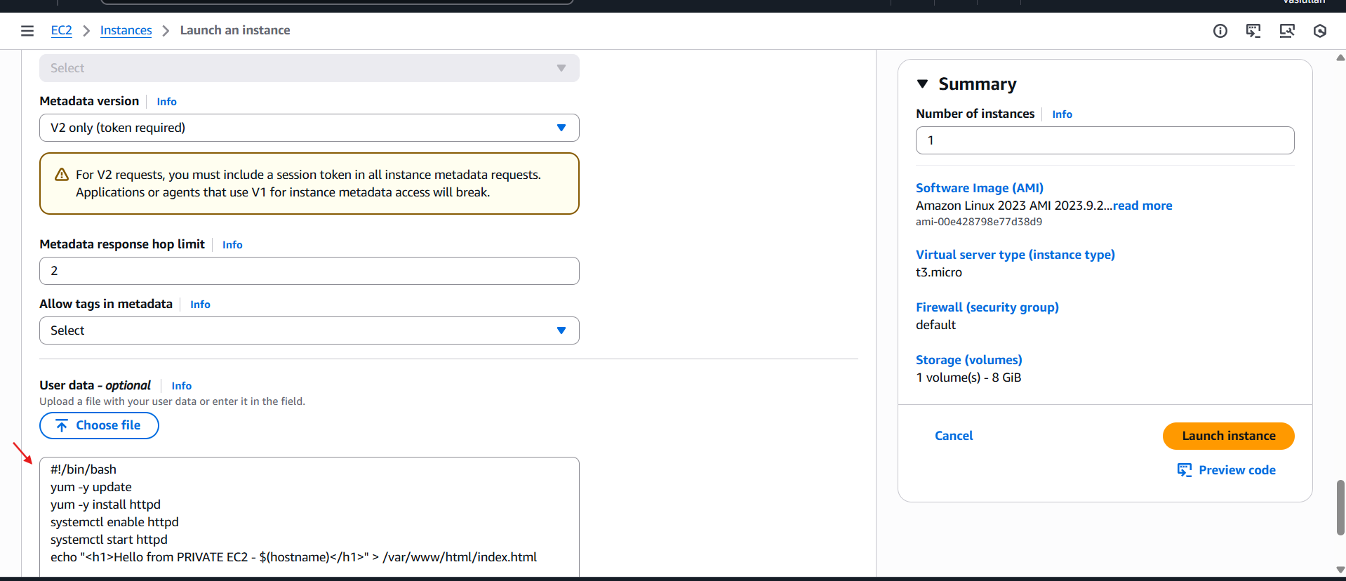

- Now to check the httpd index.html page is running login to the public ec2
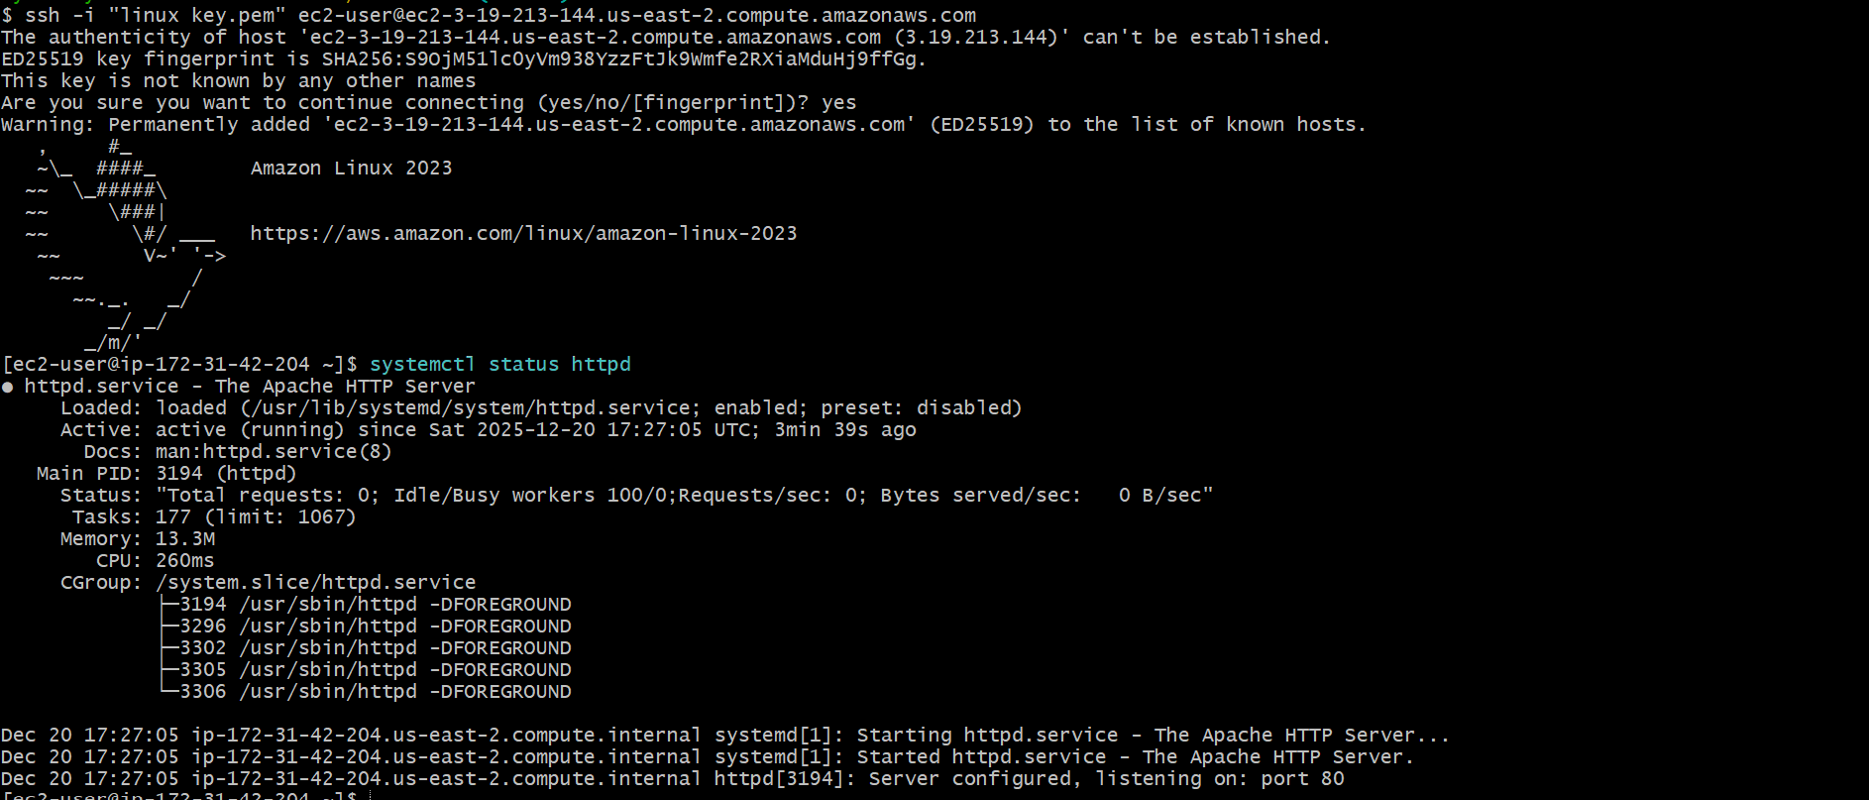

- Now browse the public ip of the public ec2 to check index.html sample page
- we can see through image the apache is running

- Now lets login to our private ec2
- step to login in private ec2
- first we have to copy the pem key by cat and
- create a file name test.pem in public instance
- And add the pem key content inside the test.pem file
- give chmod 400 for permission
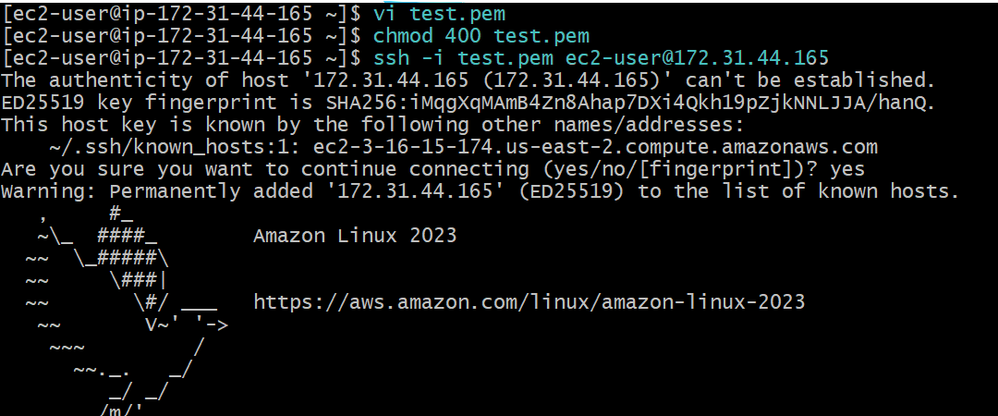

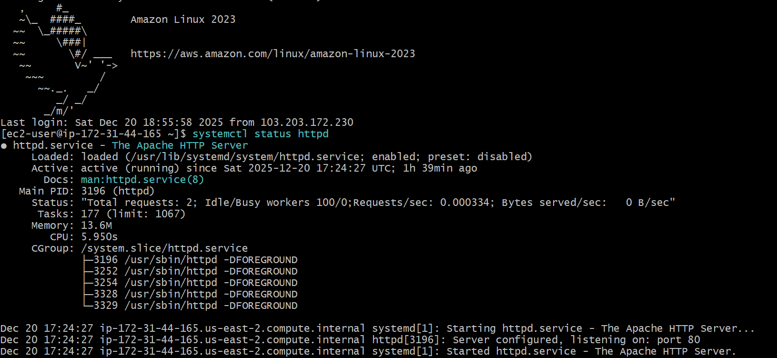

- And ssh -I “test.pem” ec2-user@
- By this we can successfully login to aur private ec2
- Now to check if it has httpd as we have connected nat gate way I should have internet access

- Create one application load balancer and attach it to both EC2 instances.

- first create a target group for the load balancer
Step 1: Create Target
- Go to EC2 → Load Balancing → Target Groups
- Click Create target group
- Choose Instances
- Target group name: my-target-group
- Protocol: HTTP
- Port: 80
- VPC: select your VP
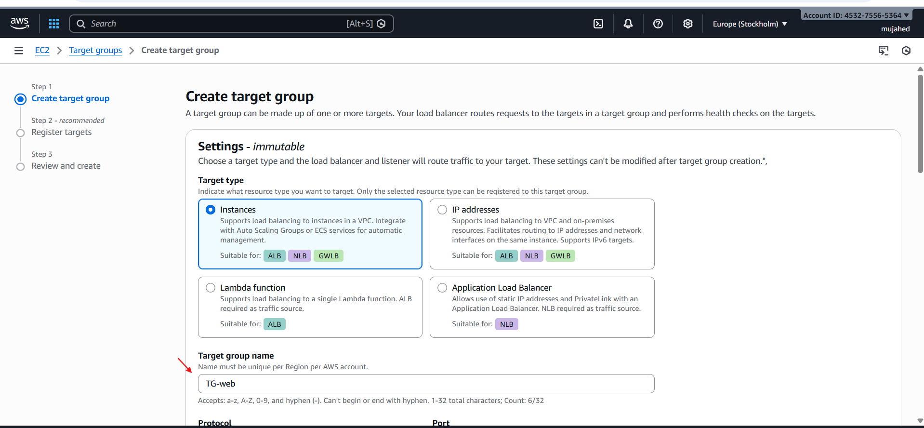

- After that click next and you will be in register target step and we have to add the instances in register target

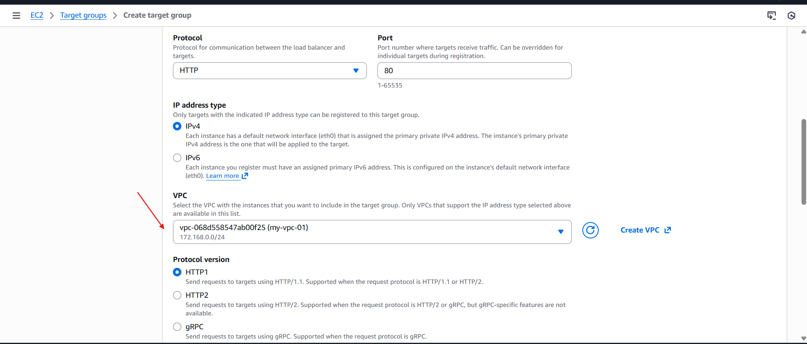
Register both instances: • public-ec2 • private-ec2 Click Create target group

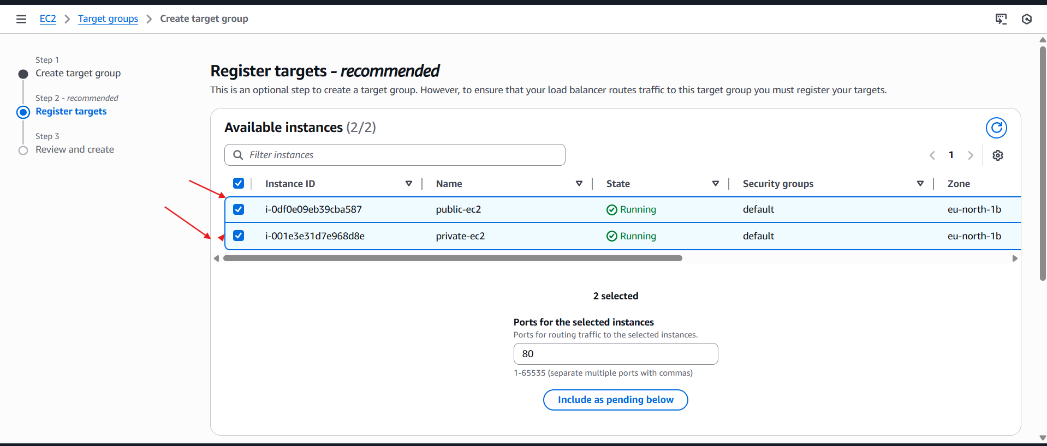
- Register both instances:
• public-ec2
• private-ec2
- Click Create target group

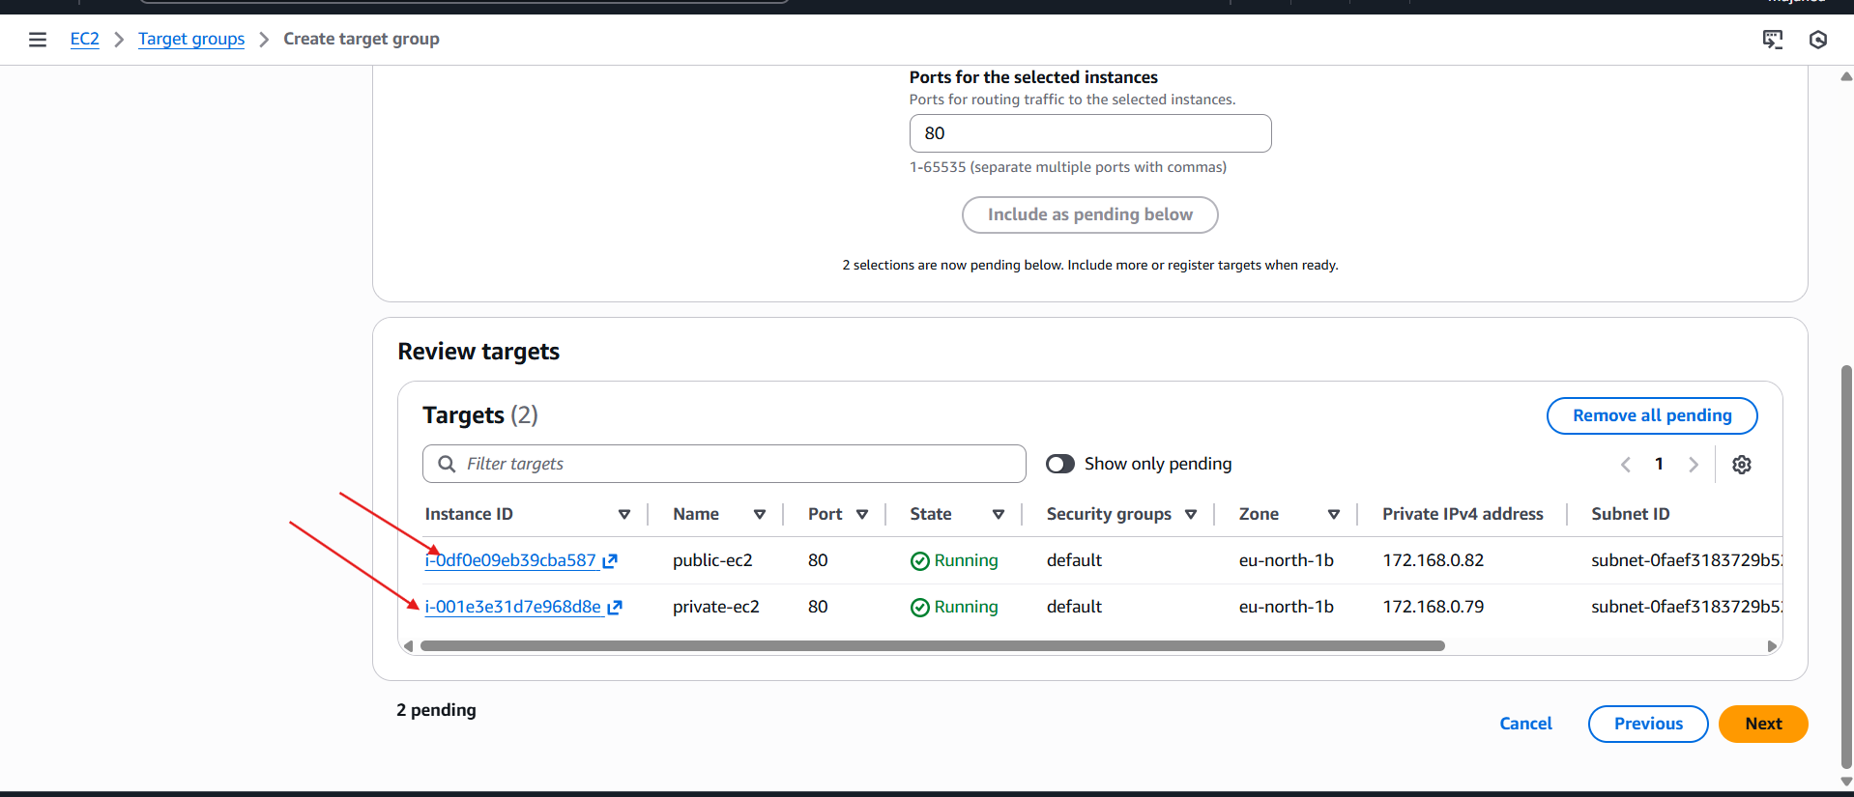
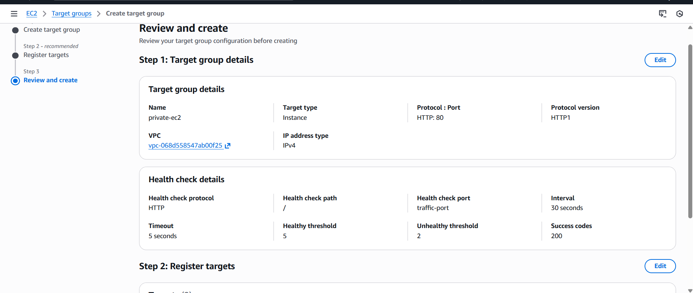
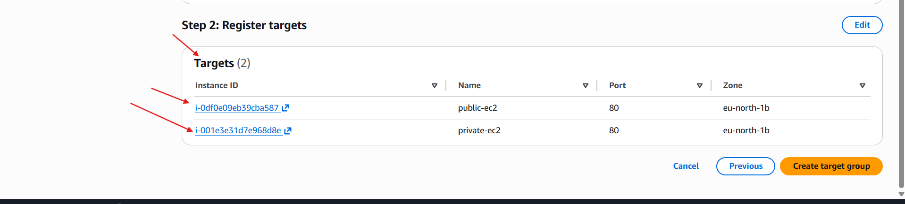

- so currently we have created a “tg-web” named target groups
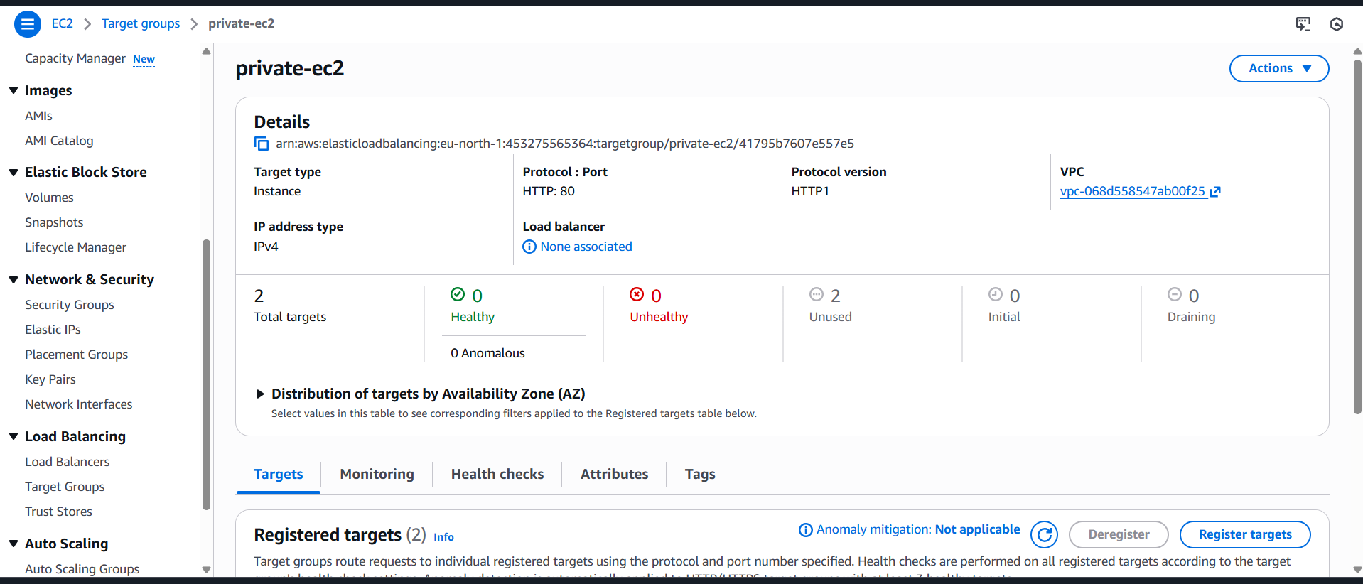
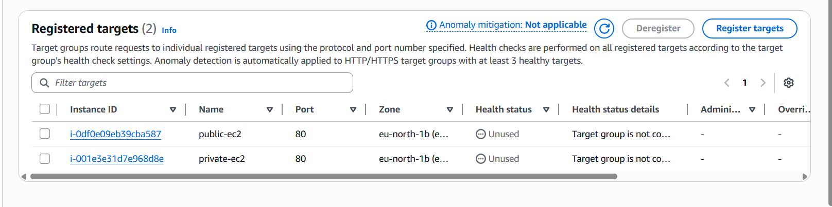

- Now we have to create load balancer
Step 2: Create ALB
- Go to EC2 → Load Balancers
- Click Create Load Balancer → Application Load Balancer 3. Name: my-alb
- Scheme: Internet-facing
- IP type: IPv4
- Select 2 public subnets (must have IGW route)
- Security group:
- Allow HTTP (80) from anywhere
- Listener: ◦ HTTP:80 → select my-target-group
- Click Create Load Balancer
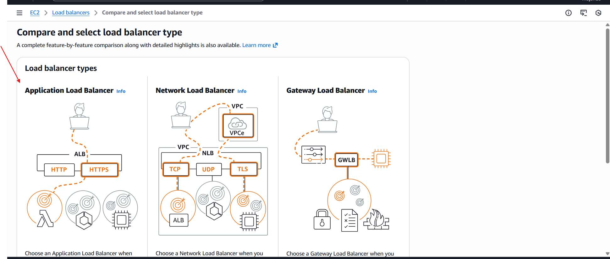
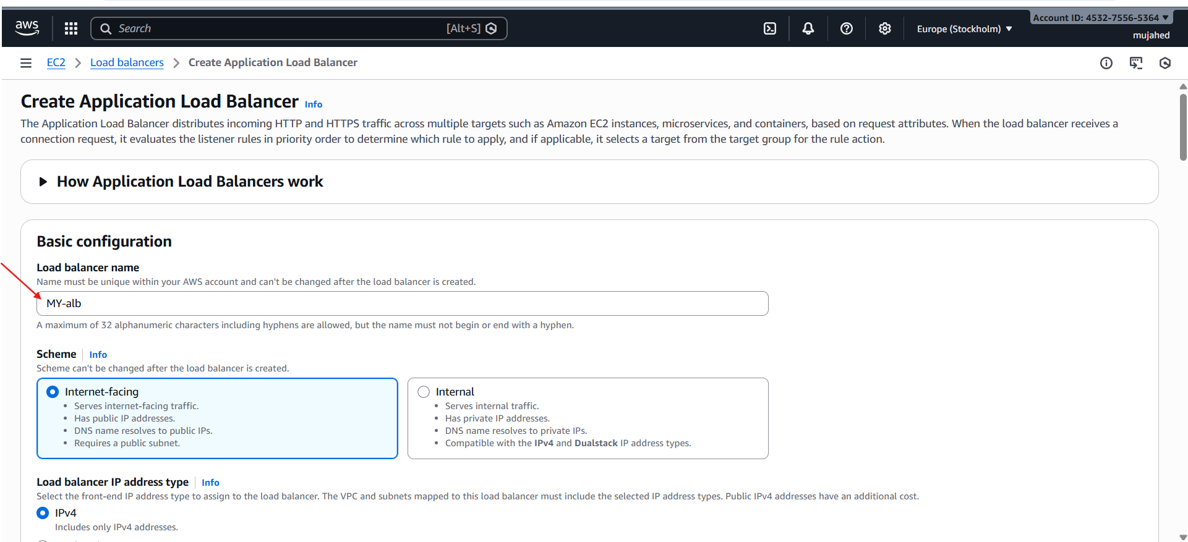
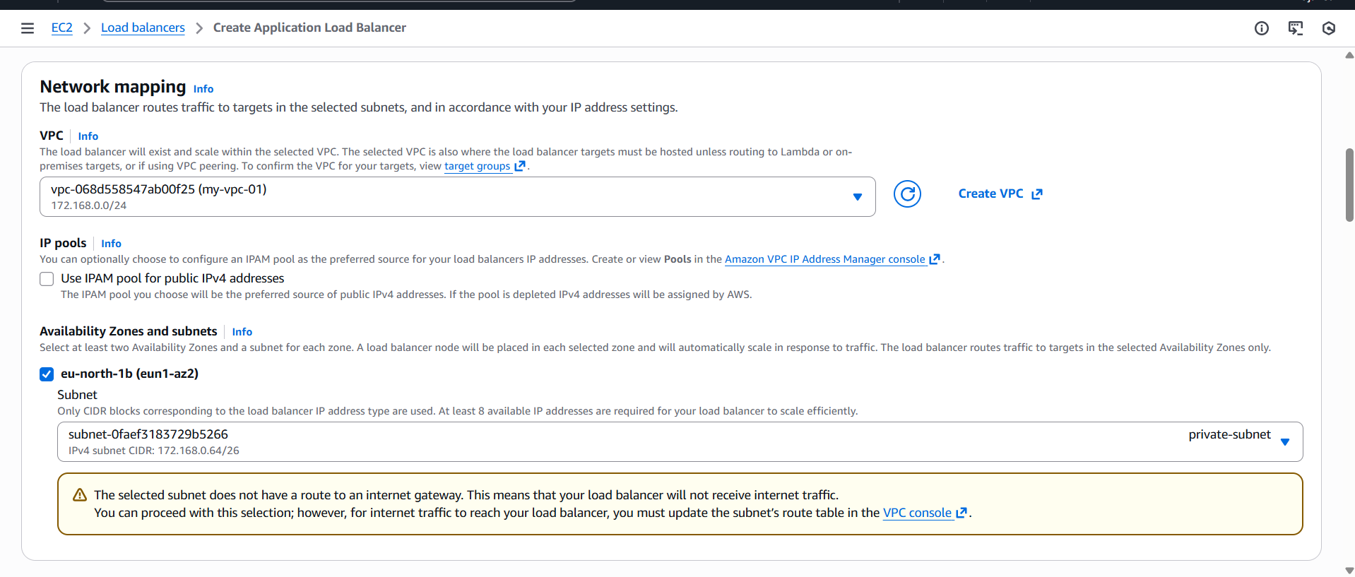
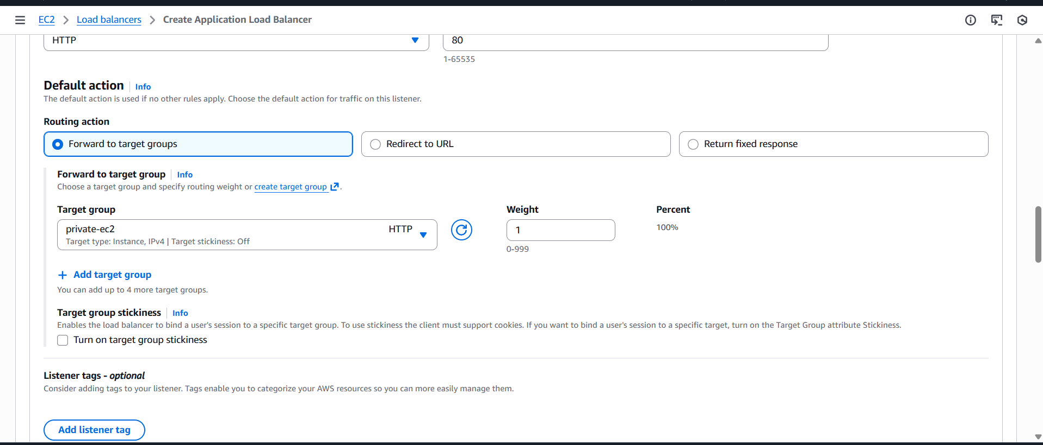

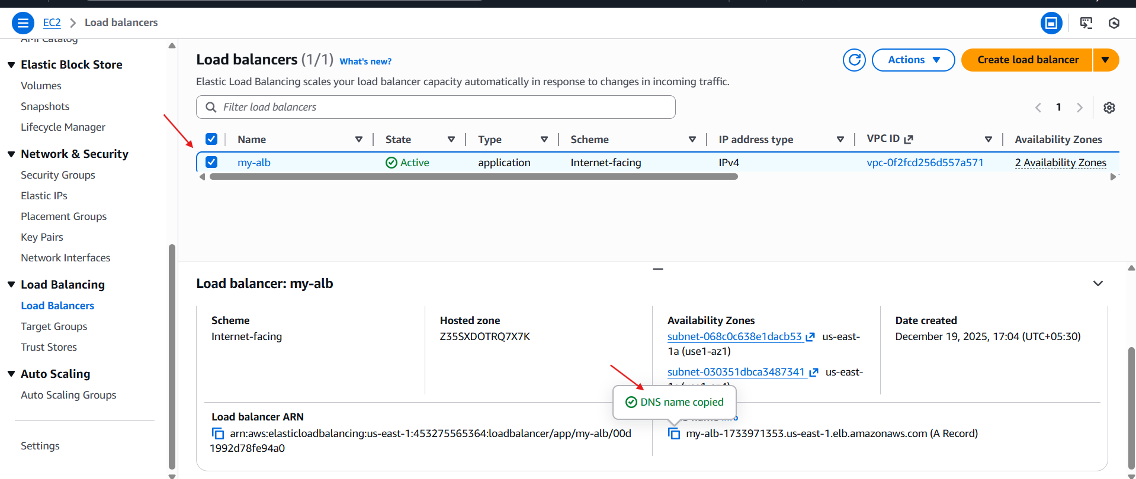

- By this we have successfully created a application load balancer for and we have attached it with subnets (ec2)

- Store application load balancer logs in S3.

- To store the logs of load balancer we have to create a s3 bucket Named with that load balancer
- I given the “my-alb-logs-vasi” as bucket name
- Block public access → Keep ON (default)
- Create bucket
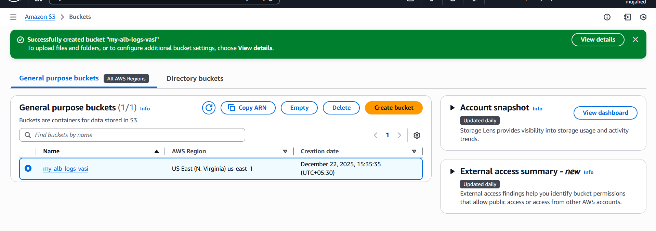
- give the bucket policy for storing logs from load balancer

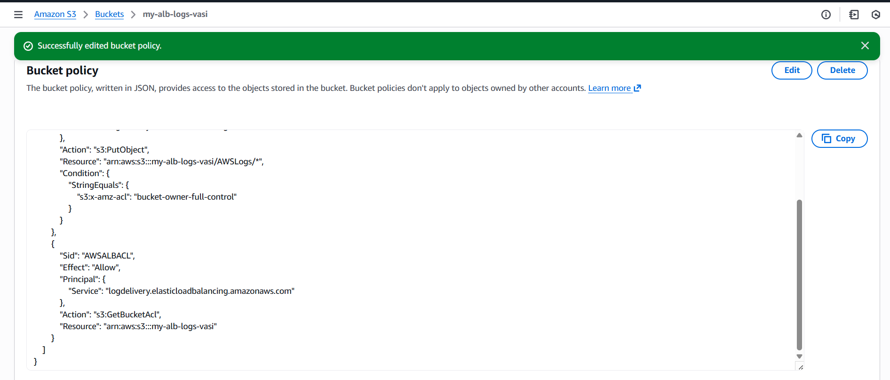
- Now go to the load balancer —> my-alb—> and look for attributes
Enable ALB Logs
- Go to EC2 → Load balancers → my-alb
- Click Attributes
- Enable: Access Logs → ON
- Provide S3 bucket name: browse the name of the bucket which we created
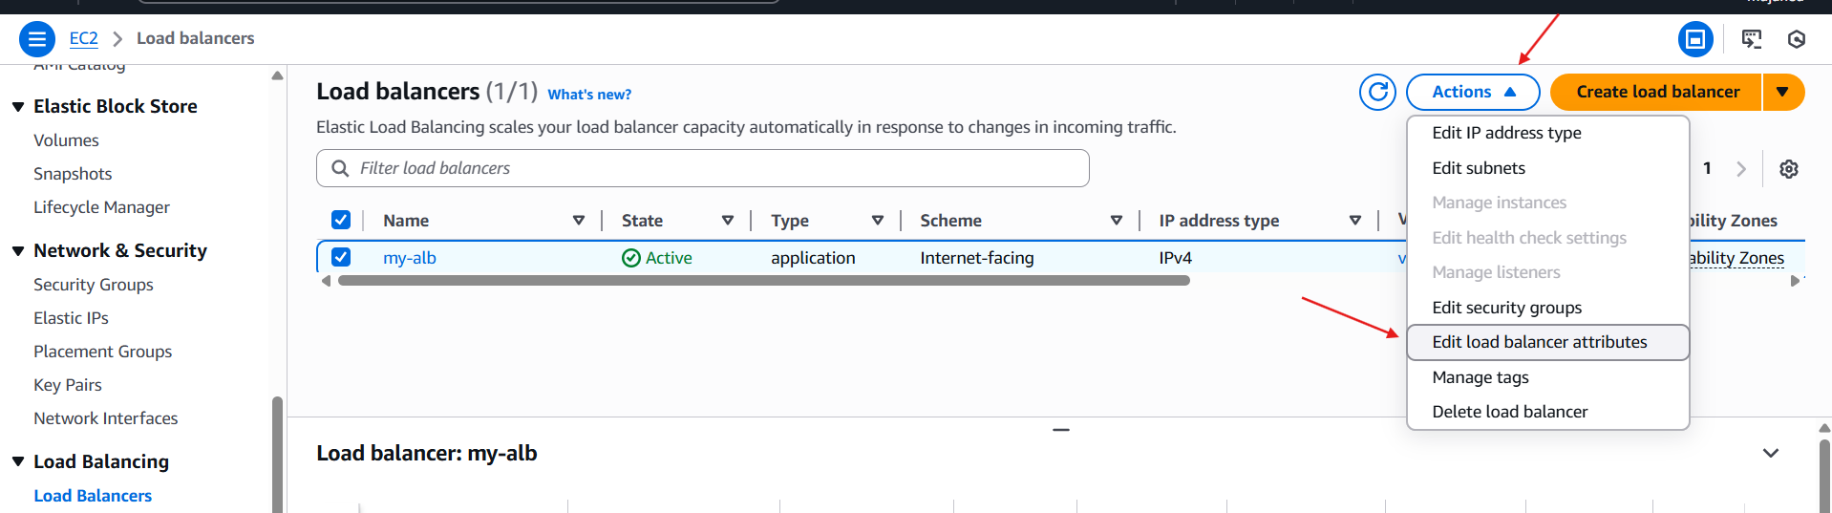
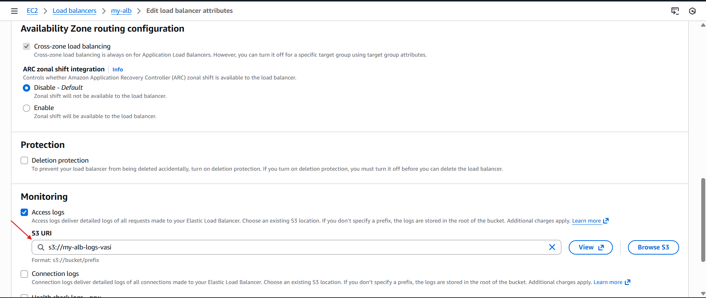

- After this step click next
- After few minutes logs will appear inside S3.

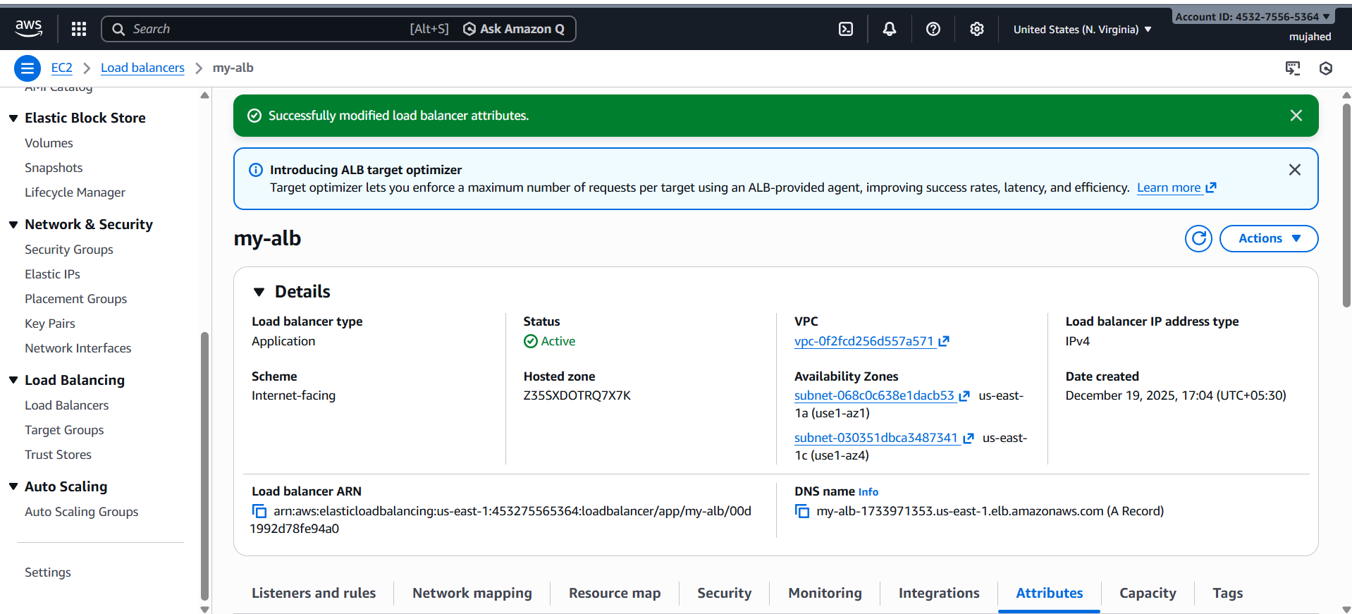
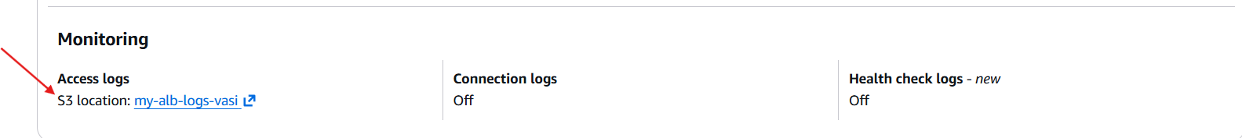
- To view this logs go to the bucket and view object

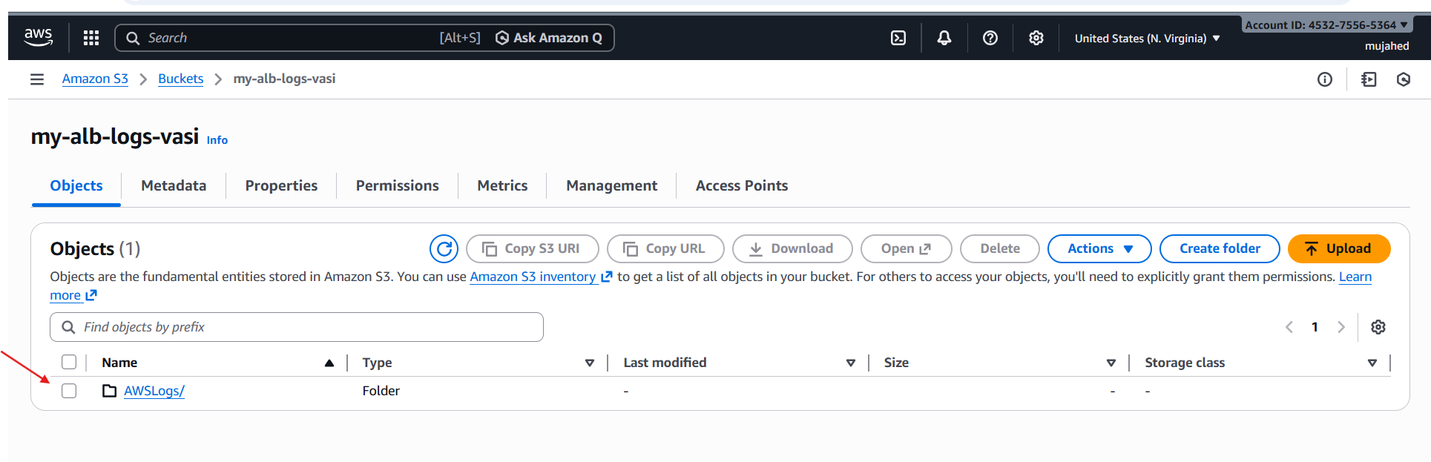
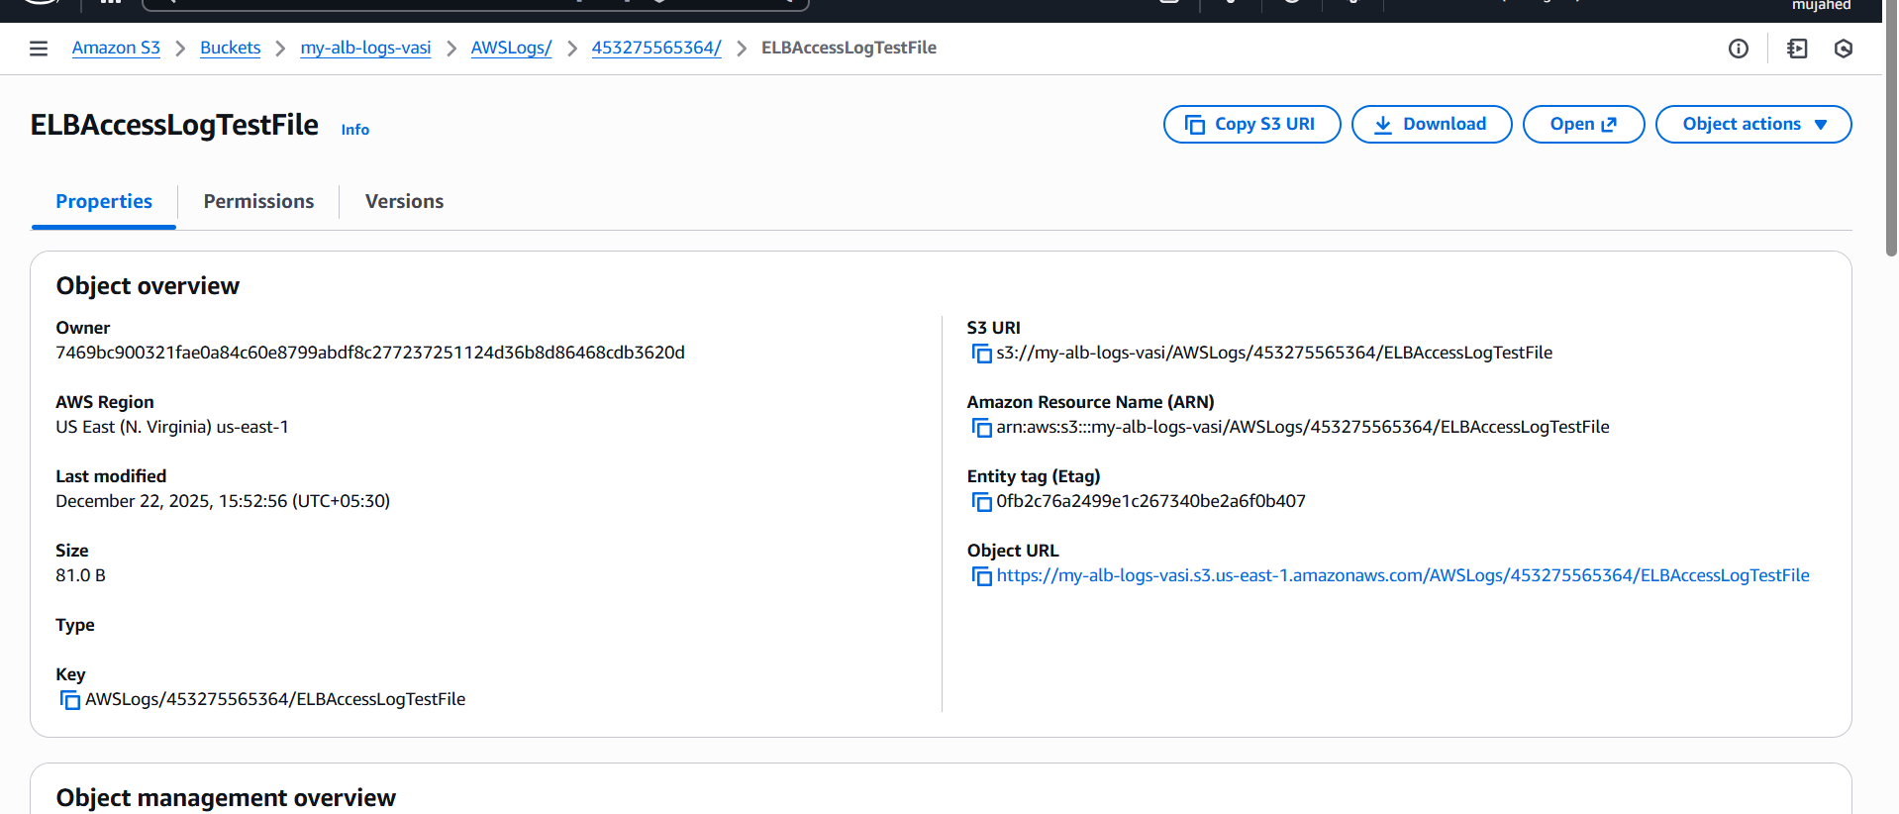
- load balancer logs are being stored in our s3 bucket

10.Store the VPC flow logs in a CloudWatch log group.

- It will record all incoming + outgoing traffic inside your VPC (like who connected, from which IP, which port, etc.)
- steps:
- Create VPC Flow Logs
- Send flow logs into CloudWatch Log Group
- Not to S3 bucket
1: Open VPC Console
- Go to:
- AWS → VPC → Your VPCs Select your VPC
2: Create Flow Log
- After selecting your VPC:
- Left side → Flow logs → Click Create flow log

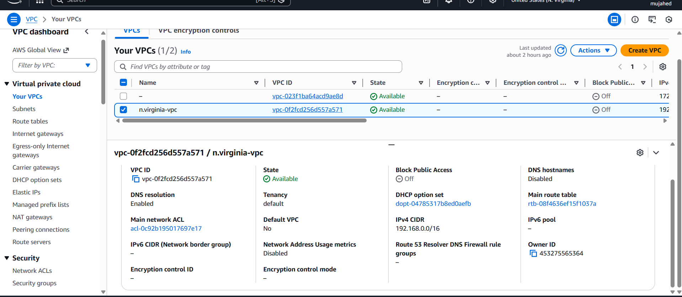
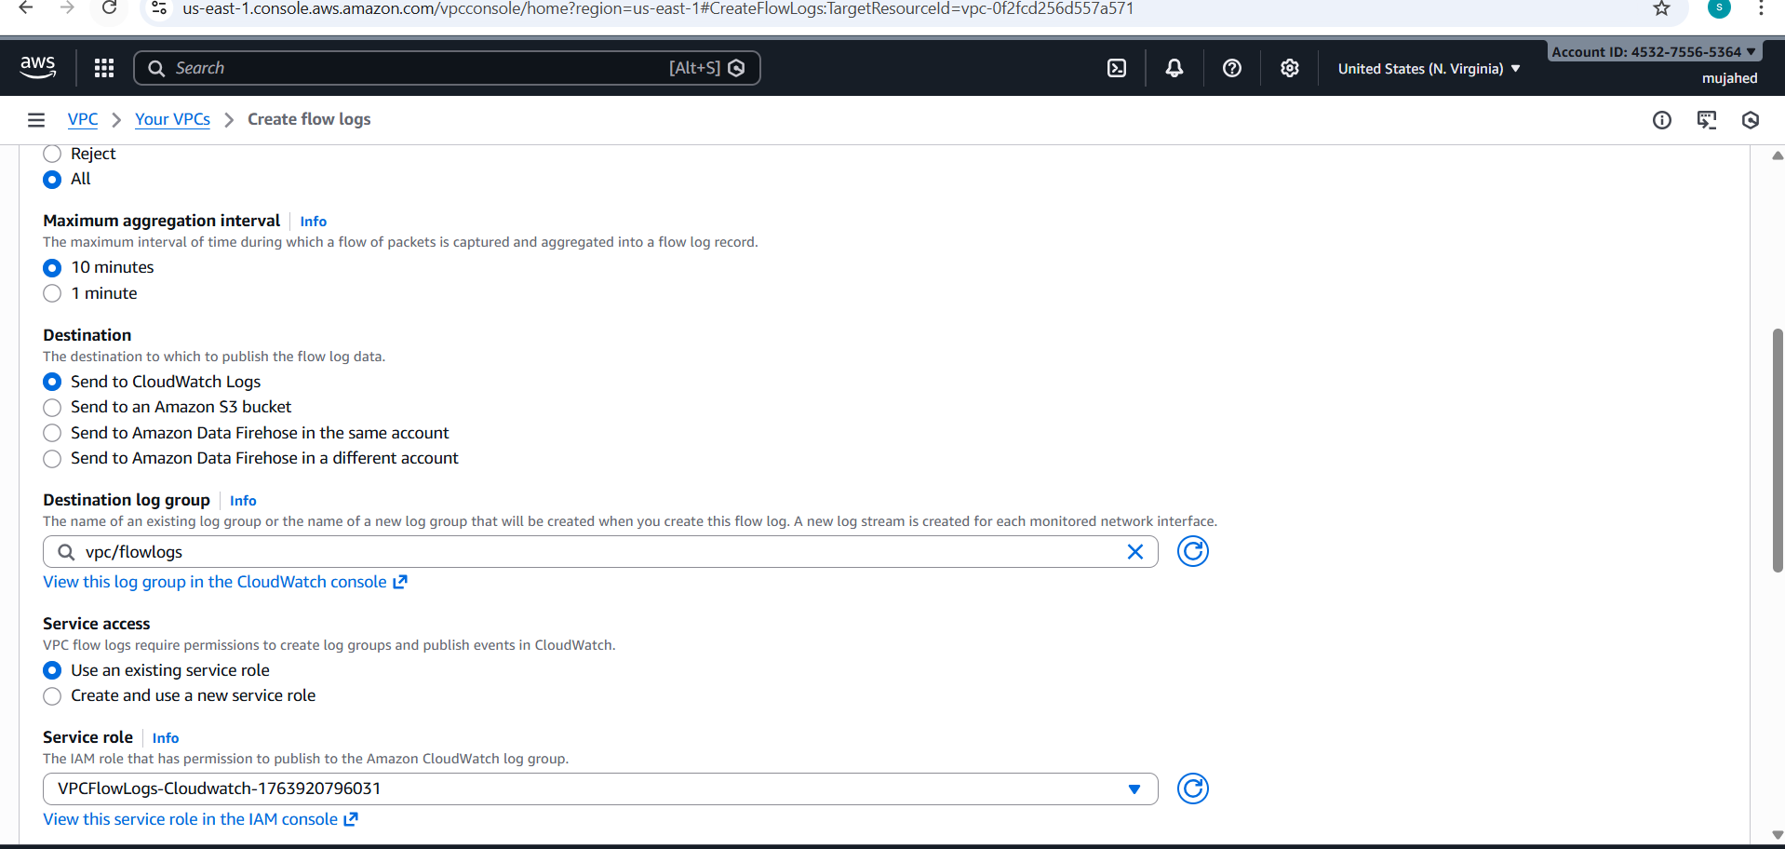

- Correct Settings You Should Select
- Filter: All
- Max aggregation:1 minute
- Destination :Send to CloudWatch Logs
- Destination log group : vpc flowlogs ==> give a role name and keep other settings default
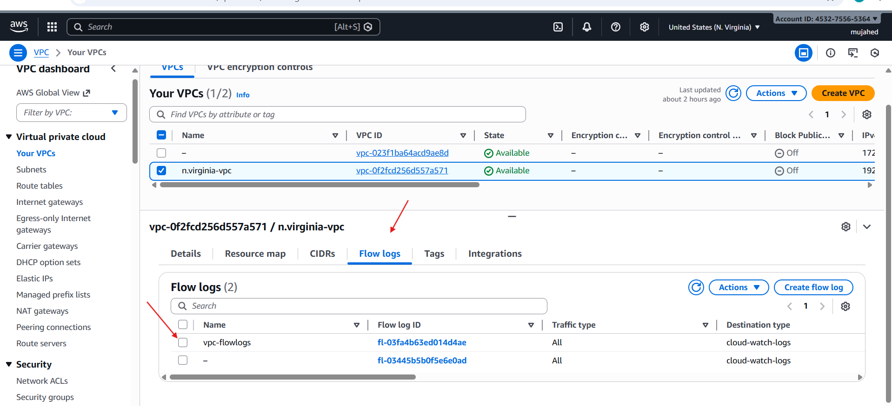

- What You Should See Next
- Inside CloudWatch:
- Log Groups → /vpc/flowlogs
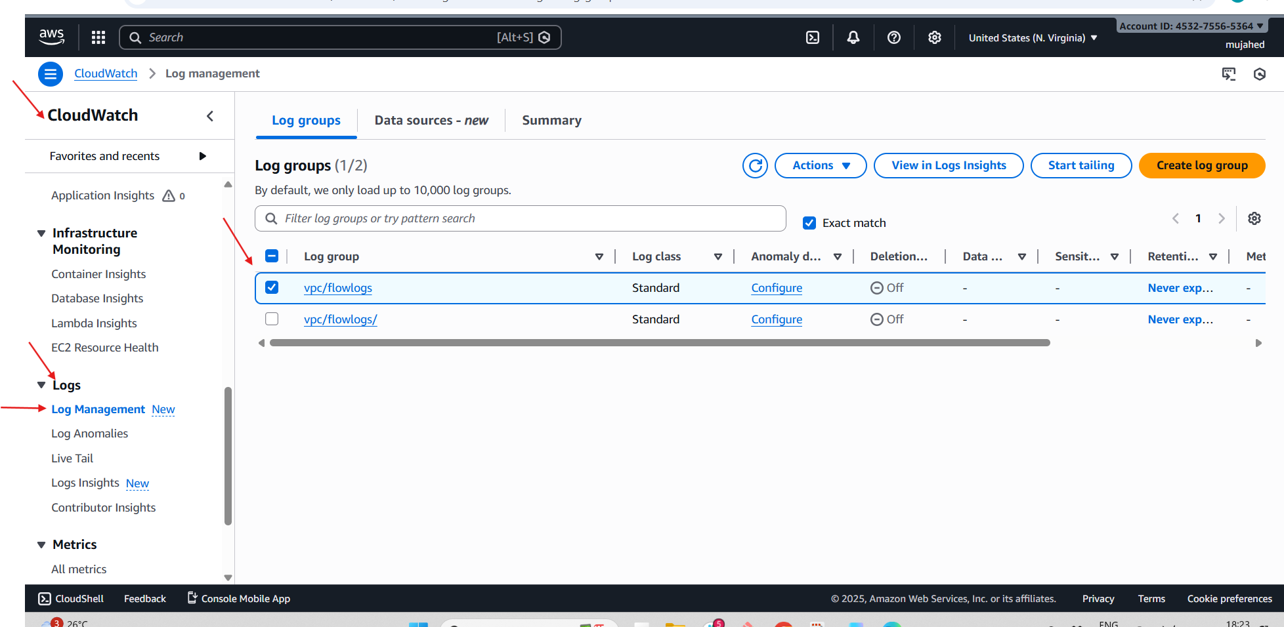
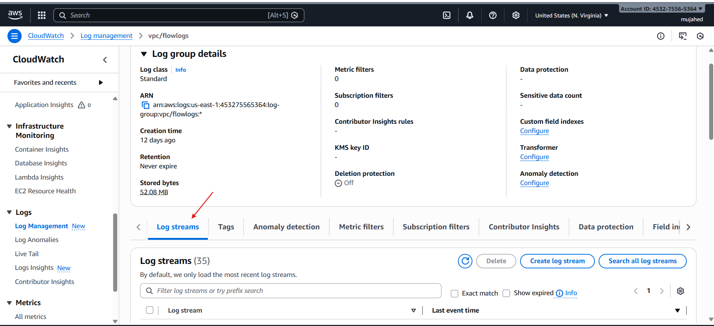
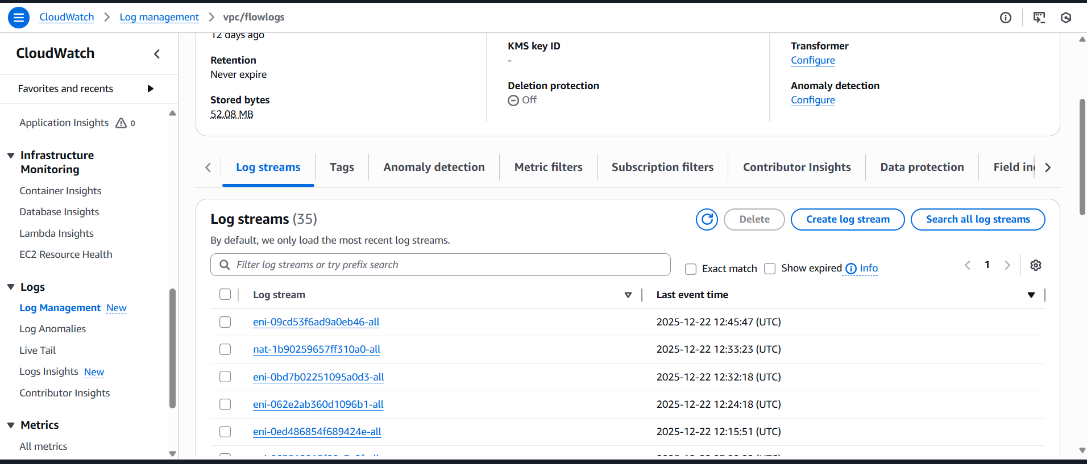

- VPC Flow Logs are WORKING properly and being sent to CloudWatch Log Group vpc/flowlogs

11.Create monitoring dashboards to monitor CPU utilization and to monitor the Apache service.

- create monitoring dashboards for CPU utilization and the Apache service, you will need to utilize AWS CloudWatch to aggregate both standard and custom metrics.

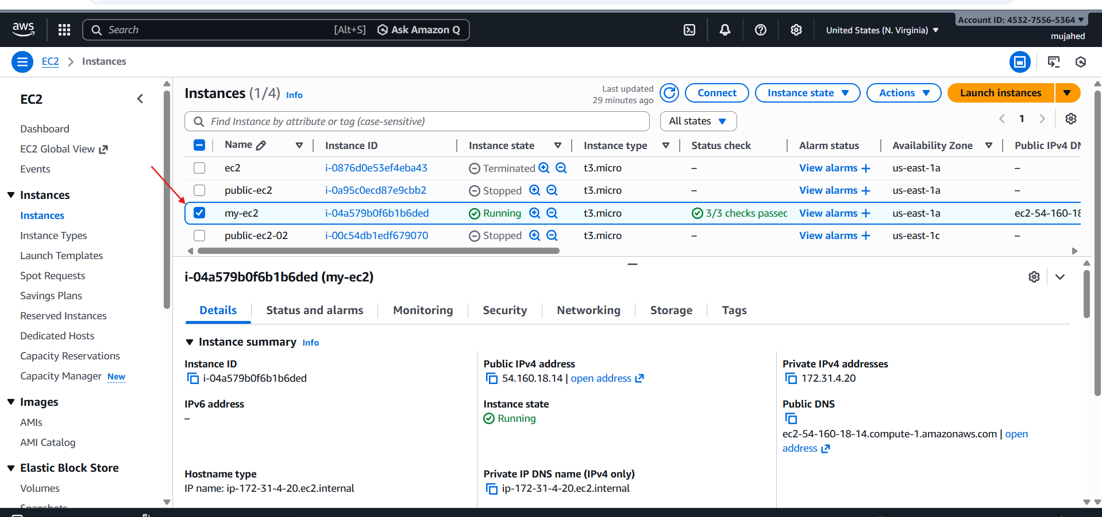

- (CPU) and software availability (Apache) of an EC2 instance by consolidating metrics into a single, centralized CloudWatch dashboard.
- An active EC2 instance (e.g., my-ec2 with ID i-04a579b0f6b1b6ded) running Amazon Linux 2023.
- The Apache HTTP Server (httpd) installed on the instance.
- sudo yum install httpd.
- sudo systemctl enable --now httpd.
- Navigate to the CloudWatch Console and select Dashboards.
- Click Create dashboard and name it (e.g., httpd).

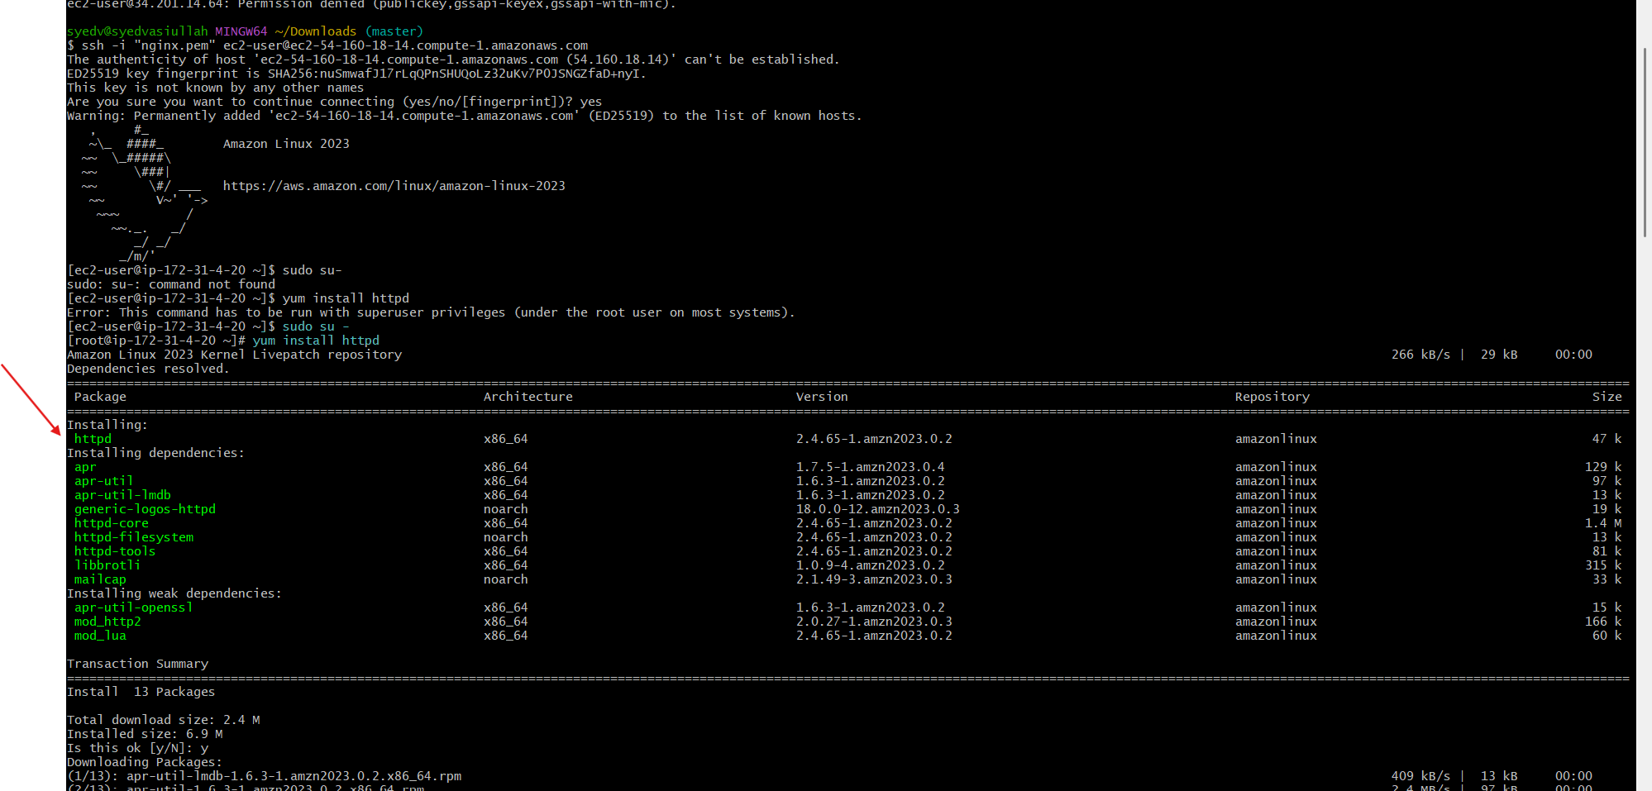

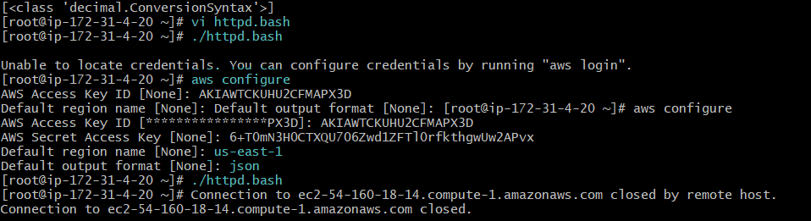

- Choose a Line or Number widget.
- Select AWS/EC2 > Per-Instance Metrics and find CPUUtilization for your instance.
- Check Dashboard Visibility: Verify that the new dashboard httpd appears in your Custom Dashboards list.
- Missing Credentials: The custom script may fail with an "Unable to locate credentials" error if aws configure has not been completed.

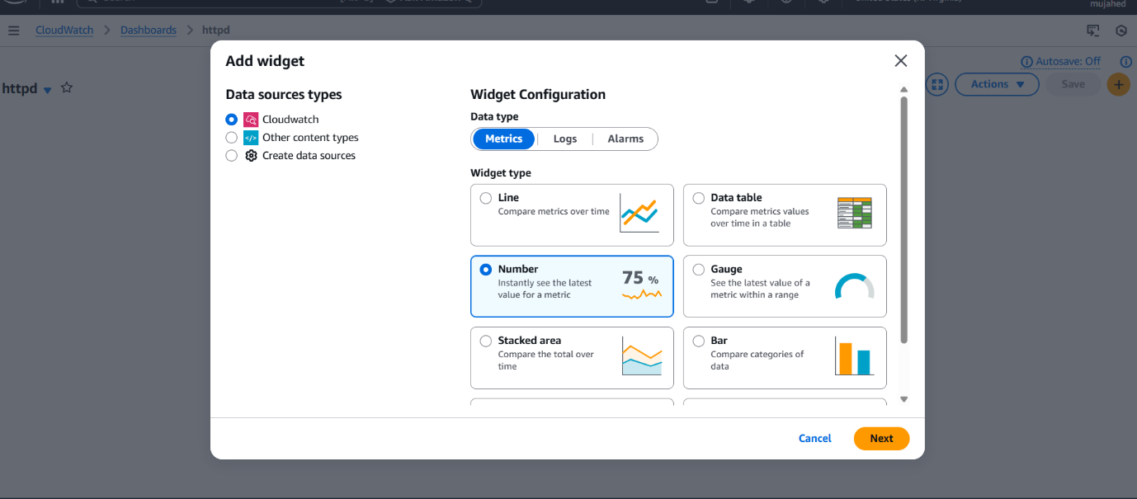
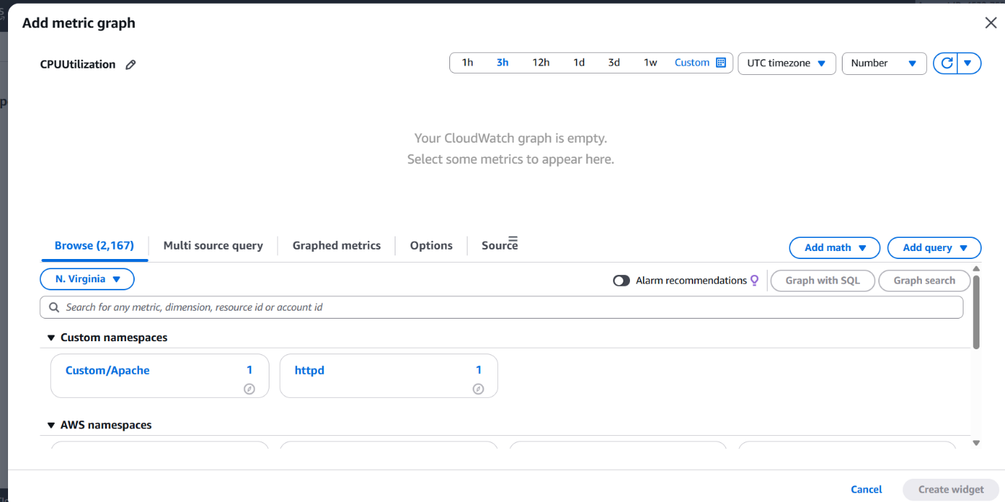

- Empty Graphs: If the custom metric is not sent frequently enough, the CloudWatch graph may appear empty initially until several data points are collected.

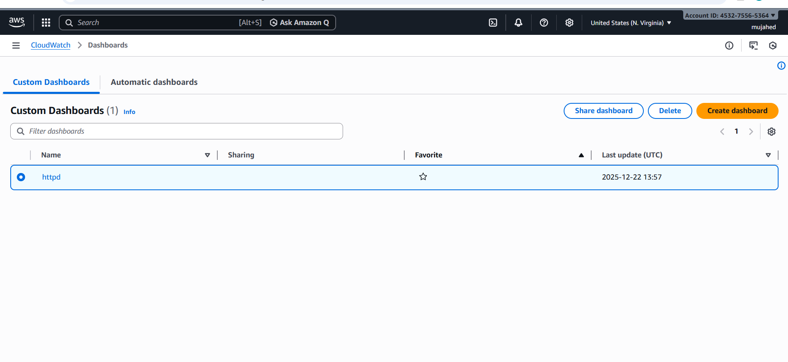

12.If CPU utilization is more than 70%, then it should trigger auto scaling and launch new instance.

- To trigger auto scaling at 70% CPU:
We need 4 things:
- Launch Template (your EC2 configuration)
- Auto Scaling Group (ASG)
- Target Group already exists (we used it for ALB) → we will attach ASG to this
- Scaling Policy: CPU > 70% → Add 1 instance
- we have to create a launch tamplate
- Create Launch Template
- Go to:
- EC2 → Launch Templates → Create launch template Fill these:

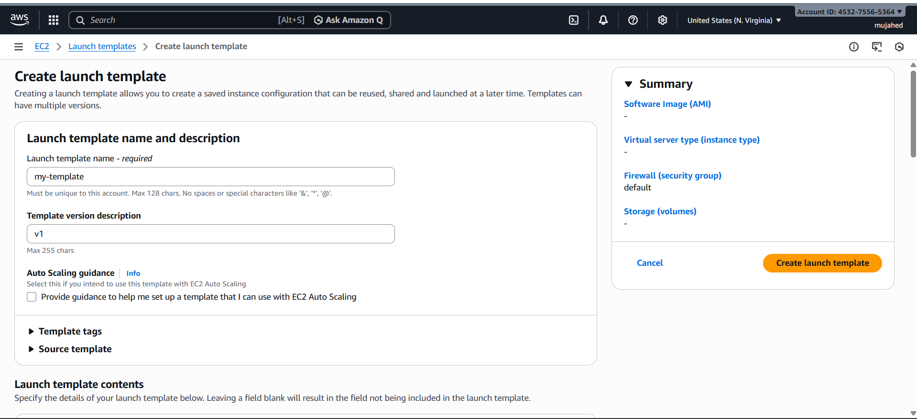

- Template Name: my-template
- select the ami and key pair and SG group
- And create the launch templete

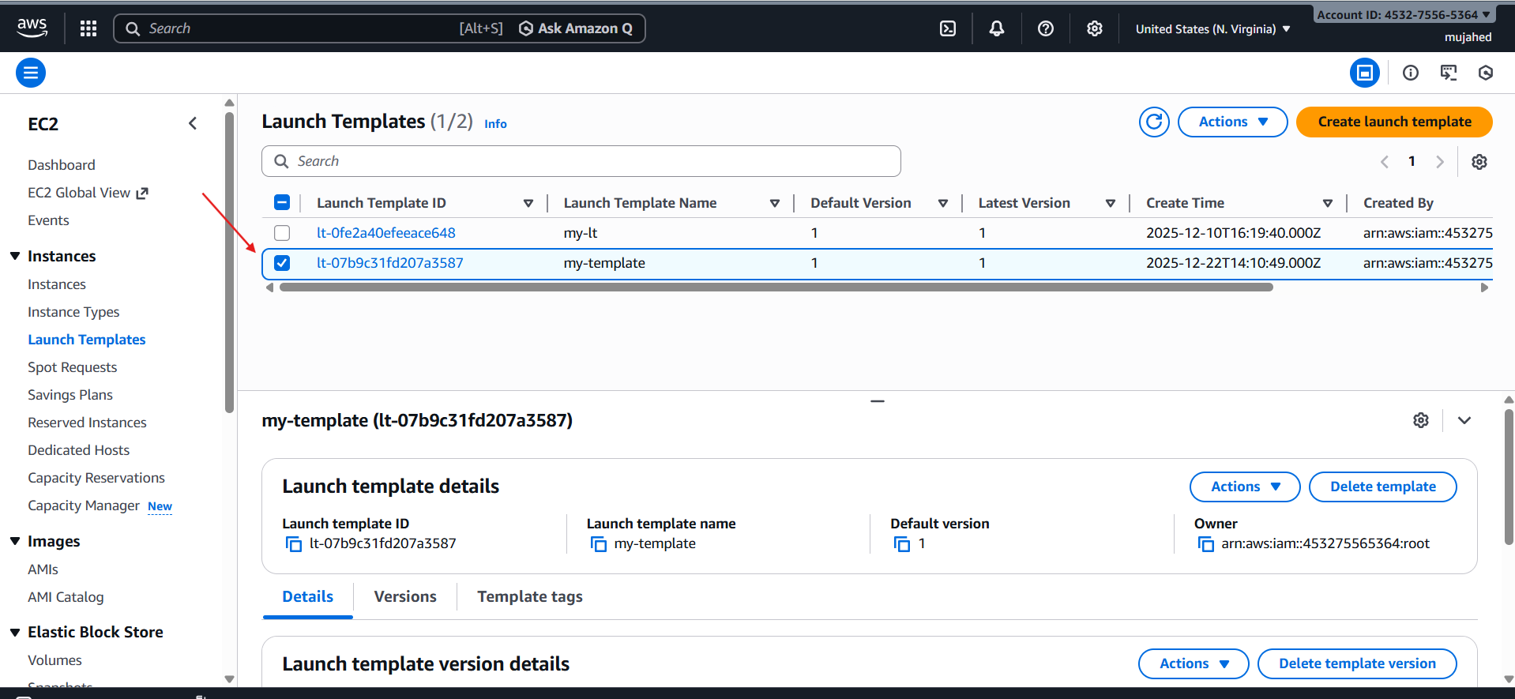

- EC2 → Auto Scaling Groups → Create ASG
- In very first select the launch template which we created
- Next select the vpc which we created and then select the availability zones of subnets from that vpc
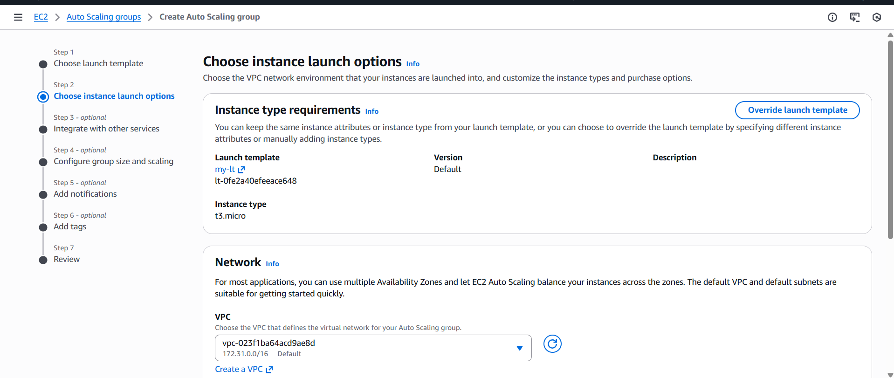
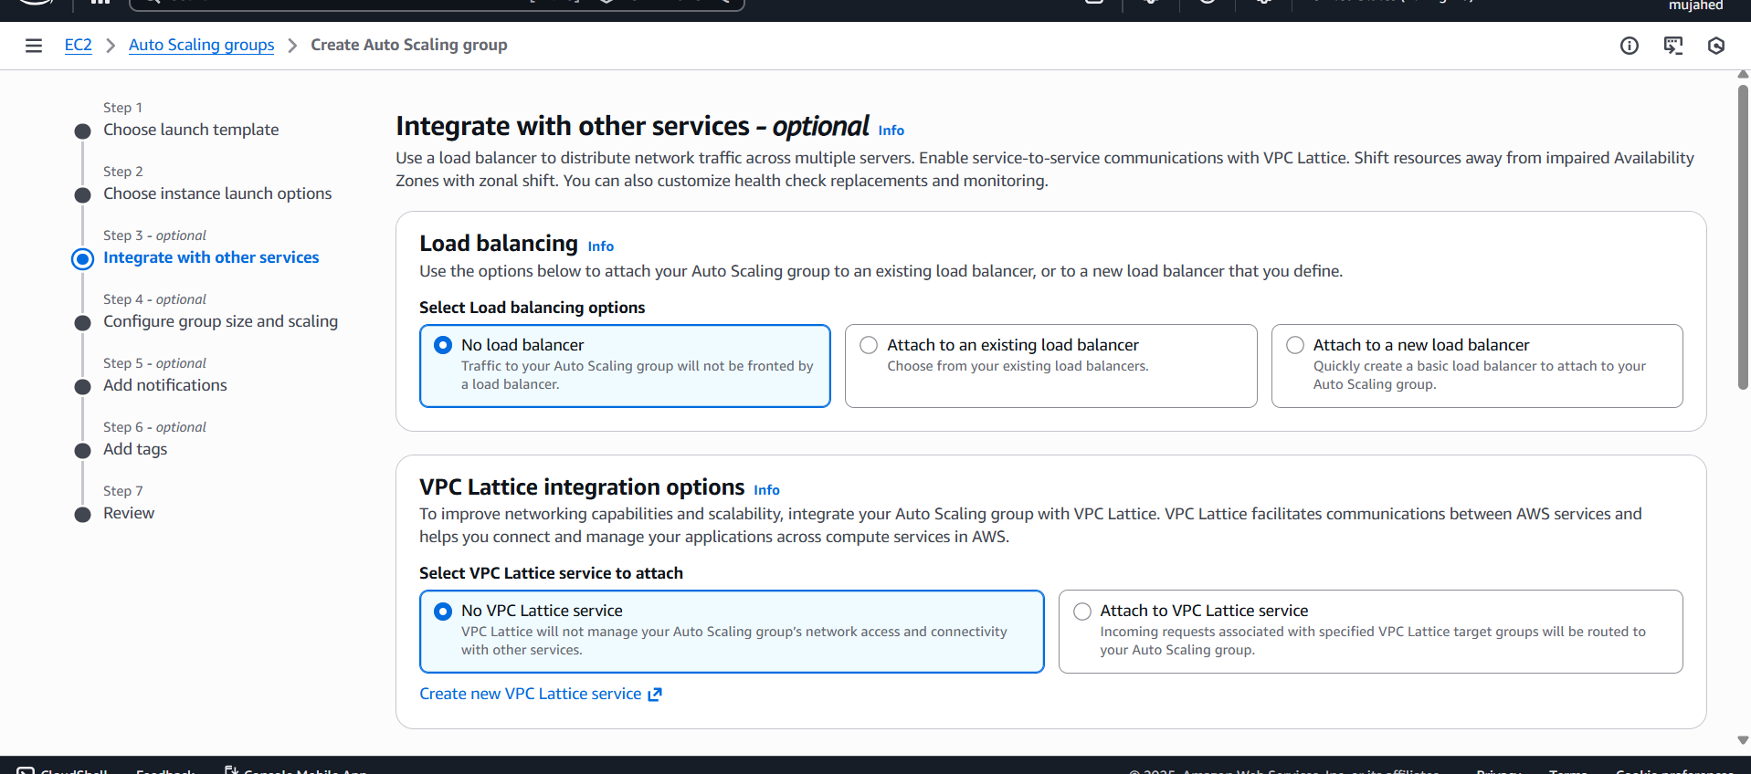
- Set Group Size scaling
- Desired capacity: 2
- Minimum capacity: 1
- Maximum capacity: 2
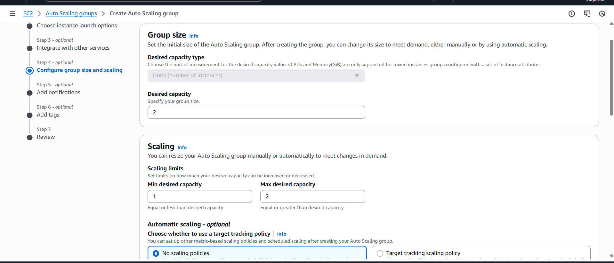
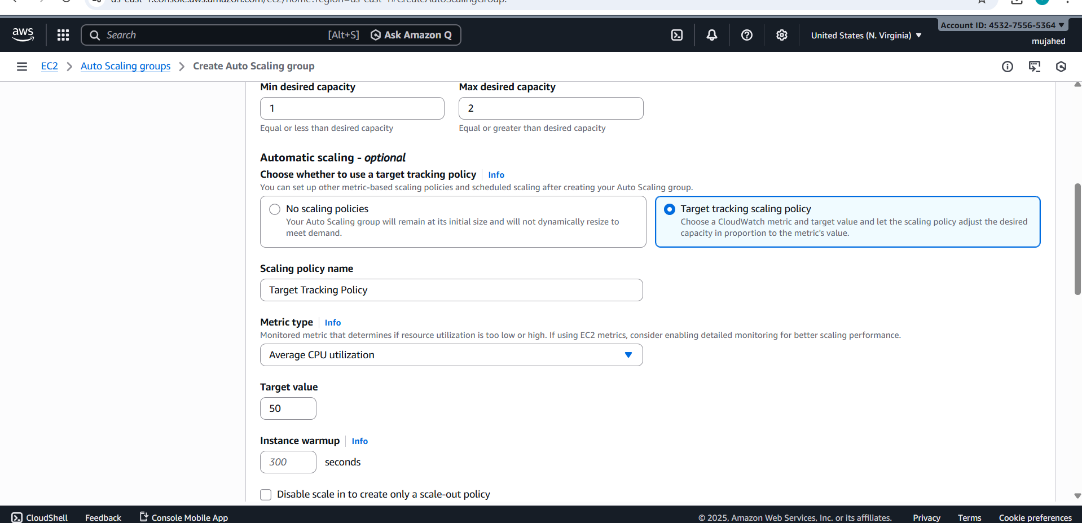

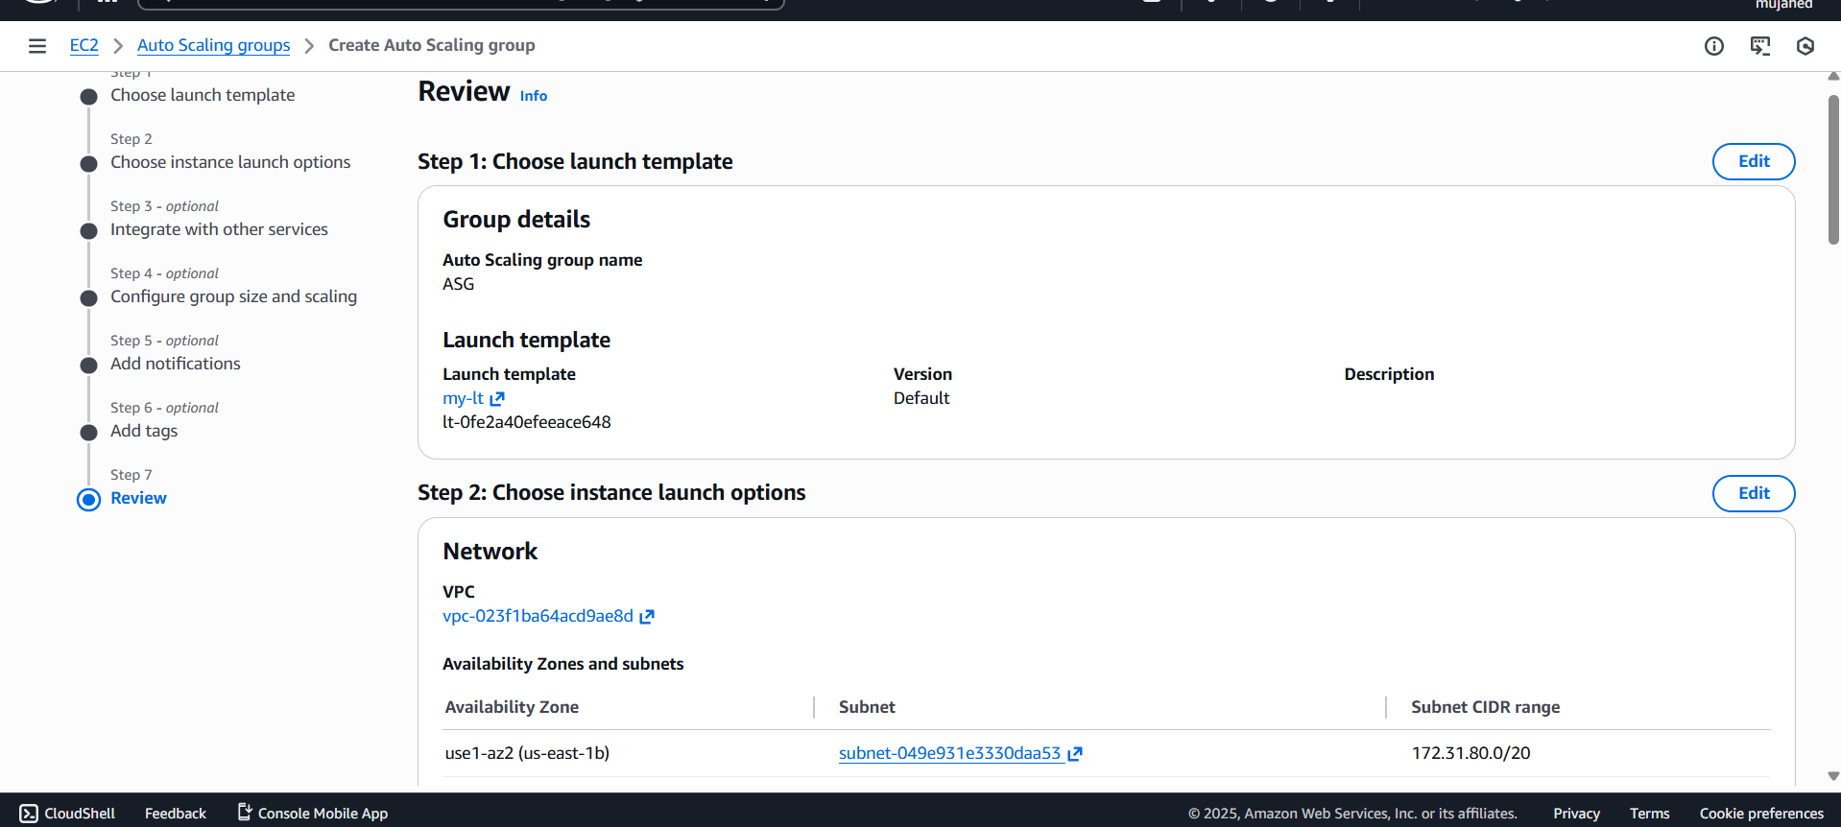

- Watch CPU of all EC2 in the group
• If CPU > 70% for ~2 minutes
• It launches a new EC2 instance automatically
• The new EC2 attaches to:
- Target Group
- Load Balancer
- VPC
- Security Group
Everything works automatically

